RESUME
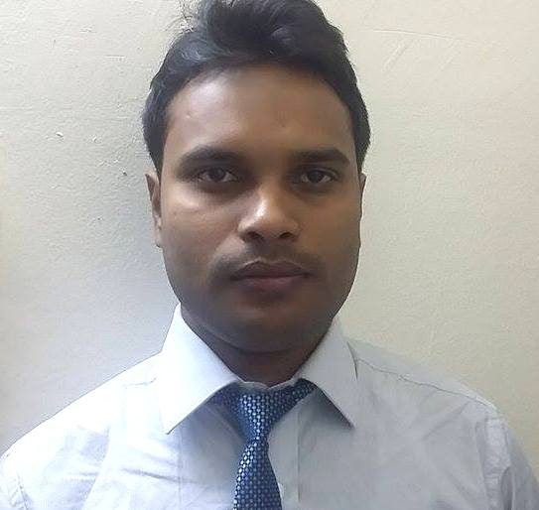

SAROJ

E-mail: 246579@gulfjobseekers.com

Visa status
Visa type: Tourist
Date of entry: 08-10-2015
Date of expiry: 08-11-2015

OBJECTIVE:
To work with full dedication in a challenging atmosphere, while adding some significant values to the organization and gain professional skills while working with support of competent peers and guidance leader which will further enhance my career ambition of rising to pinnacle of success.
EDUCATIONAL QUALIFICATION:

Exam. | Board/University | Institution | Year of completion | %age of marks
B.Pharm. | Rajiv Gandhi University of Health Sciences, Karnataka | Aditya Bangalore Institute of Pharmacy Education and Research(ABIPER),Bangalore, Karnataka | 2014 | 62.56%
HSEB(10+2) | Higher Secondary Education Board,Nepal | HariKhetan Multiple Campus,Parsa,Nepal | 2009 | 46%
Secondary  (SLC) | SLC Board,Nepal | Galaxy Public School,Kalaiya,Bara, Nepal | 2006 | 63.63%

SKILLS AND ABILITIES:
- Hardworking, Responsible, Sincere and Believe in team work
- Accept challenges with strong will power. Have good grasping power and communication skill.
- Quick Learner and Adaptable Nature
COMPUTER SKILLS:
MS-office, MS word, PowerPoint,
MS- Excel, Internet Browsing.

Special Merit:
- Health awareness program through audio-visual aids on communicable diseases, hypertension, Diabetes mellitus, Asthma, Hyperlipidemia – conducted for 1000 students of Aditya national public school during Pharmacy Week Celebrations, November 2010.

- Environmental safety, Global warming and awareness about protection from Swine flu,ird flu – organized for middle school, high school and higher secondary students of Bangalore and surrounding area schools during November 2010.3.ONE YEAR EXPERIENCE OF WORKING AS PHARMACIST AT ASWIN POLICLINIC.
SEMINAR & CONFERENCE:
1. Attended National Seminar on Application of Ionizing Radiation on Pharmaceutical, organizedby ABIPER,Bangalore-64,sponserd by BABHA, Mumbai on octeber,2013
PERSONAL DETAILS:

Date of Birth | : | 26/05/1988
Sex | : | Male
Marital Status | : | Married
Languages Known | : | English,Hindi,Bhojpuriand Nepali
DECLARATION:
I hereby certify that the information furnished by me is correct to the best of my knowledge.

Date:
Place:BangaloreYours Faithfully

