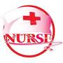
CURRICULUM VITAE
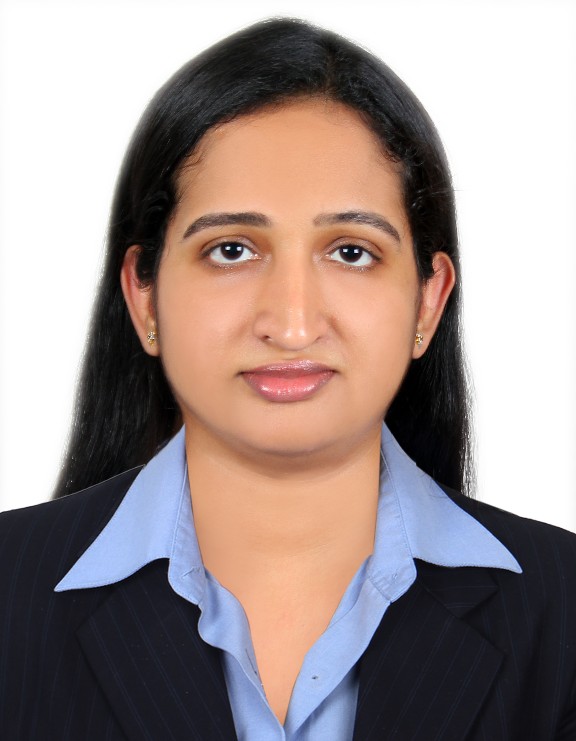
Gulfjobseeker.com CV No: 1485096
Mobile +971504753686, +971505905010
cvdatabase[@]gulfjobseeker.com
To contact this candidate use this link
http://www.gulfjobseeker.com/feedback/contactjs.php
Career Objective:

Being resourceful, Innovative, flexible and hardworking. I seek a challenging career in medical field that utilize to the fullest extend and in a professionally reputed hospital where I can apply my knowledge and skills to the best of my abilities.

Total work experience: 5 years as “Registered Nurse”
Having a Valid “Registered Nurse” License from Dubai Health Authority
(D.H.A) License No: DHA/LS/1832013/318897

Working Experience:

Employer (1) Life Line Hospital, Jabel Ali, Dubai-UAE
Period: 2014 till present
Designation: Registered Nurse
Nature of work: Registered Nurse in assisting Pulmonologist
And Gastroenterologist opd (endoscopy, colonoscopy, spirometry,
And bronchoscopy)

Employer (2) Jubilee Mission medical college, Thrissur, Kerala-India
Period: 2009 to 2013
Designation: Registered Nurse
Nature of work: Registered Nurse in assisting Gastroenterologist:-
(Endoscopy, colonoscopy and experience Gastro ICU & Ward)

Employer (3) Daya General Hospital & Specialty Surgical Centre, Thrissur,
Kerala, India
Period: 2008 to 2009
Designation: Registered Nurse
Nature of work: Registered Nurse in Surgical ICU

International Certification:


• BLS Qualified Accredited by American Heart Association

Duties and Responsibilities:
- High level cares for a variety of patients.
- Regularly participate in lengthy procedures.
- Co-ordinate pre-op clinic.
- Prepare diagnostic study reports.
- Educate patients/families on health care needs, conditions, etc.
- Schedule patients admission and discharge.
- Performing in a multi-disciplined team environment.
- Knowledge and ability to interpret biochemical and blood values.

Career Profile:
- Registered nurse with 5+ years work experience in medical surgical departments.
- Strong knowledge in UAE insurance processing approvals, paper works for submission of approvals.
- Experience in handling endoscopy, bronchoscopy, spirometry, sleep study.
- Strong analytical skills in life threatening emergency and implement appropriate intervention.
- Demonstrate aptitude for developing new skills.
- Readily develop rapport with patients, families, staff and other health care professionals.
- Relate well to people from a variety of cultures and socio-economic conditions.
- Dedicated individual, reputation for consistently going beyond what is required.

Professional Qualifications:

Course : BSC NURSING
Year of Passing out : 2008
Institution : ShRIDEVI COLLEGE of nursing, KARNATAKA, india.

Academic Qualifications:

Course : Secondary School Leaving Certificate
Board/University : Kerala Board, Passed out in 2001
Institution : Holy Family .Kerala. India

Course : Plus Two Certificate
Board/University : Kerala Board, Passed out in 2003
Institution : GHHS Villadam, Thrissur

Computer Knowledge

- Knowledge of Microsoft Office which includes Excel, Word ,office Outlook and Internet research

Personal Details
Date of birth : 04/01/ 1986
Religion : Christian
Nationality : Indian
Visa Status : Residence Visa (Husband sponsorship)
Gender : Female
Marital Status : Married
Languages Knows : English, Hindi, Malayalam, Tamil, kannada and beginner in Arabic

Declaration

I do hereby declare that all above furnished matters are true and correct to the best of my knowledge and belief.

