Muhammed

Email: 248393@gulfjobseekers.com

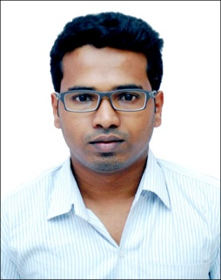
Career Objective:
To work in a meaningful and challenging position that enables me to develop myself as a professional and permits scope for advancement with utmost dedication and commitment to the mission and vision of the team and the organization
.
Academic Qualifications:

Course | Institution/Place | Board/  University | Year of  Completion | CGPA /  Grade obtained
B.E  (Biotechno-logy) | NMAMIT,  Nitte | Autonomous  under VTU | 2014 | 6.92  (62.2%)
2nd PUC/HSC | Govt. Pre-University college, Byndoor | Karnataka PU Board | 2009 | 60.5%
SSC | HMMMS English medium school,  Byndoor | Karnataka  Secondary  Education  Board | 2007 | 81.28%

Experience:

- Worked as process associate in Arthur J. Gallagher in Pune, Maharastra in 2015

Project undertaken:

- Production of bio-ethanol from non edible seed oil.

Seminar and workshops attended:

- Workshop on Personal Effectiveness in 2011 conducted by Computer Society i-point.
- Immersive Group Workshop held by i-Point Mangalore.

Competencies:

- Effective in communication.
- Quick learner and hard working.
- Programming languages known : C language.

Extra-Curricular activities:

- Volunteered for International Conference on Recent Advance and Challenges in Biotechnology.
- Singing.
- Participated in cultural activities in Tech-fest and Anandostava 2011,12.

Certification:

- Certified for successfully completing in all required course works and pre-process training for Finance & Accounting, conducted by Arthur J Gallagher, Pune.

Personal Details:

Date of Birth: 13th March 1992

Languages known: English, Hindi.

