Gulfjobseeker.com CV No: 1492776
Mobile +971504753686, +971505905010
cvdatabase[@]gulfjobseeker.com
To contact this candidate use this link
http://www.gulfjobseeker.com/feedback/contactjs.php 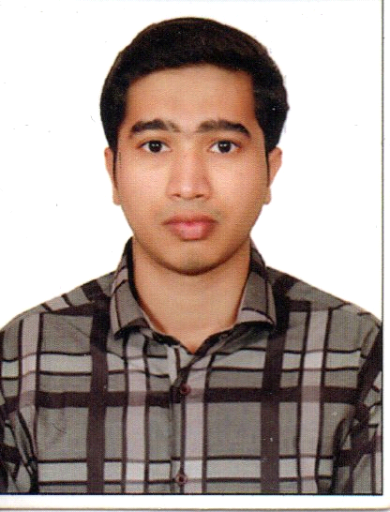

Curriculum vitae

OBJECTIVE:

A position in result oriented organization that seeks an ambitious and carrier conscious individual, where acquired education and skills will be utilized towards continuous growth and advancement. I hope to hear from you at your convenience.

Academics

- M.B.A. (Master of Business Administration , Human Resource Management), University of Madras (2015-2016, Pursuing )
- B.com (Bachelor of Commerce), THE NEW College for Men Chennai, University of Madras (2009-2012)
- H.Sc, Kumara Rajah Muthiah Higher Secondary School. Adyar, Chennai. State Board (2008-2009)
- S.S.L.C., Kumara Rajah Muthiah Higher Secondary School. Adyar, Chennai. (2006-2007)

COMPUTER SKILLS:

- TALLY ERP9
- Windows, Ms Office, Dos, Internet, Ms Excel, Pivot Table, Look up
Functions, Date & Time, Text Functions, Math Formula, Data and Macro
- MS Office (word, power point, Excel, spread sheet)
- Operating System (windows xp, windows 7 & windows 8 )

Additional Qualification:

. Typewriter ENGLISH

Work Experience▼ SPARKLING DIAMONDS Mumbai ,India

Duration : may 2012 - march 2015
Position : Accounting & Export & Imports

Role & responsibilities:
- Prepare Profit and loss statements on behalf of a business.
- Set up accounting practices and procedures for new companies and advise on how
to manage these.
- Analyse budgets and other financial information and advise where savings could be
made.
- Help to produce budgets for business and implement strategies for cost savings.
- Ensure company accounts and tax returns are prepared and filed correctly and on time.

personal Particulars:

Date of Birth : 01.08.1991

Sex : Male

Marital Status : Single

Nationality : Indian

Religion : Muslim

Languages known : English,Tamil & Hindi

Driving licence : INTERNATIONAL DRIVINING LICENCE

Training & Seminar:
- Attended personality development seminar in THE NEW COLLEGE college for Men Chennai.
- Presented seminars on various subjects related to commerce and Business entrepreneurs.

Extra Curricular Activities:

- Books Reading
- GYM
- Sports activities- Playing cricket and volly ball.
Visa Status
- Visa Type : Tourist / Visit Visa

Declaration:

I declare that the details furnished above are true to the best of my knowledge.

Place: Dubai,

