JINIL
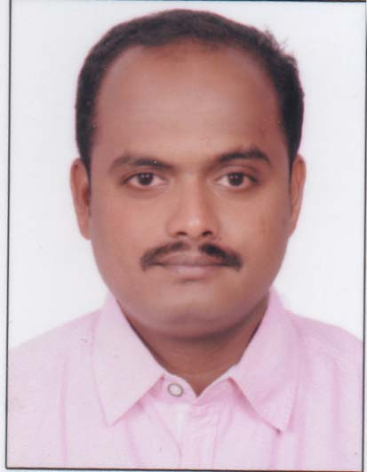
JINIL.252004@2freemail.com

OBJECTIVE
To obtain an HR Assistant and/or Benefits Coordinator position where I can fully utilize my experience, training skills and energy to contribute to profitability, teamwork, and company success. To continue to develop and apply knowledge in order to support Human Resource requirements and functionality.
PROFILE
Detail-oriented professional with fourteen years’ experience as an Administrative Assistant, HR Support and Benefits Coordinator. Congenial, self-starter, highly organized individual with a strong work ethic and a proven track record of reliability and determination.

COMPUTER SKILLS
Effective knowledge in a variety of business computer systems and programs including: Microsoft Outlook, Microsoft Excel, Microsoft Word, Word Perfect, Payroll Systems, Tally, On-line Benefits Web-sites
PROFESSIONAL EXPERIENCE
Nav Jeevan Mission School, Deoria, and Gorakhpur, UP – India 01/04/2016 – Present
Geeta Wholse Mart, Gorakhpur, UP – India Oct. 2015 – Mar. 2016
Kristal Group, Kochi - India Jan. 2015 – Aug. 2015
Little Flower School, Rapti Nagar, Gorakhpur, UP – India Apr. 2012 – Dec. 2014
St. Joseph's Higher Secondary School, Baramulla, J & K – India Feb. 2010 – Mar. 2012
Little Flower School, Dharampur, Gorakhpur, UP – India Feb. 2004 - May 2009
Kristu Jyoti Convent School, Samba, J&K - India Feb. 2003 – Feb. 2004

Administrative Assistant to Controller / Office Manager:

Responsible for office work-flow management, scheduling appointments, accounts payable, payroll, insurance administration, bank reconciliations, customer service, developing a procedures manual, creating and maintaining proper documentation, correspondence, inventory control, and various reports.

Organized and maintained the business office including, but not limited to: payroll, personnel records, new employee orientation, benefits coordination, and compliance. Developed forms and procedures, organized quarterly staff meeting/luncheons within a budget, created agendas, organized and hosted special events, created, facilitated and scheduled employee orientation and managed calendar

Instrumental in creating certain procedures regarding customer service to maximize efficiency and minimize transaction time. Created a system to track company credit card possession and use. Obtained discounts from certain vendors and set up company records retention system.

Recognized for ability to greet each task with confidence and a positive attitude. Consistently rose to meet new challenges and create ways to accomplish whatever was required to “get the job done.”

Entab Infotech Pvt Ltd, New Delhi - India Jun. 2009 – Dec. 2009

Project Engineer for implementing the software in India and Saudi Arabia:

Software Implemented in the following school:-
- International Indian School, Riyadh (K S A)
- Al-Noor International School, Jeddah (K S A)
- Radhwa International School, Yanbu (K S A)

Product Name: Campus Care (Institutional Management Solutions)
- Campus Care provides solution for Institutional Automation covering all the functional areas of an educational institution.
- The software is divided into different modules like Student Information, Admission, Examination, Fees, Payroll, Financial Accounting, Library, Time Table, Mess management, Inventory, Hostel Management, which are integrated to provide a centralized mechanism.
- The front end of the software is made with VB, VB.Net along with the support of Seagate Crystal Reports, a tool used for Report Generation.
- Back end of the software is managed with SQLSERVER.
- Campus Care also have web browsing system for institutional automation covering the modules such Student Information, Fees, Examination which is coded using ASP.NET (VC#.NET) and SQL Server, Crystal Reports in which I have got 2 Years of experience.
- Six months worked in Riyadh, Jeddah and Yanbu as Sr. Software Engineer through the Entab Infotech Pvt. Ltd. New Delhi(15-6-2009 to 15-12-2009)
EDUCATIONAL QUALIFICATIONS

Month & Year Of Passing | Institute Name & Location | Qualification Code | Branch Code | Marks Obtained (in percentage) | University Code
MARCH, 1999 | HOLY INFANT BOYS HIGH SCHOOL, VARAPUZHA, KERALA | 10 | GENERAL | 52 | KERALA BOARD
2010-2011 | GRADUATE IN DIPLOMA | GDM (GRADUATE IN DIPLOMA MANAGEMENT)  SPECIALIZATION IN  FINANCES MANAGEMENT | - | A+ - GRADE | B - SCHOOLS
IN 2003  (6 Months) | PRISM TECHNOLOGIES, KERALA | DCA (DIPLOMA IN COMPUTER APPLICATION) | GENERAL | A – GRADE | --
IN 2004  (3 months) | KAWA INSTITUTE, SAMBA, J&K | COMPUTER HARDWARE AND NET WORKING COURSE, J&K | GENERAL | A - GRADE | --
IN 2004  (3 Months) | KAWA INSTITUTE, SAMBA, J&K | TALLY 7.2 (ACCOUNTING PACKAGE) | GENERAL | A - GRADE | --

EXTRA CURRICULAR ACTIVITIES & ACHIEVEMENTS

- Driving [Saudi & Indian License (Photocopy)] and Playing Badminton.
DECLARATION
I hereby declare that all the statements made above are true to best of my knowledge and belief.

JINIL

