COVER LETTER

3 year experience in India

Dear Sir/Madam,

I’m pleased to submit my application for the appropriate position in your esteemed organization. I have completed my three year diploma course of Institution of Civil engineers on April, 2012. And also have 2 years of experience since August, 2013 in the field of site supervisor and 1 year experience as Draftsman.

I am a conscientious person who works hard and pays attention to detail. I'm flexible, quick to pick up new skills and eager to learn from others. I also have lots of ideas and enthusiasm. I'm keen to work for a company with a great reputation and high profile like yours. I would be delighted to discuss any possible vacancy with you at your convenience.

Please go through my CV that details my past academic credentials and experiences.

I would be delighted at an opportunity to participate in a personal interview to answer any of your questions and better present my qualifications. Thank you for your time and kind consideration and I look forward hearing from you very soon as possible.

CURICCULAM VITTE

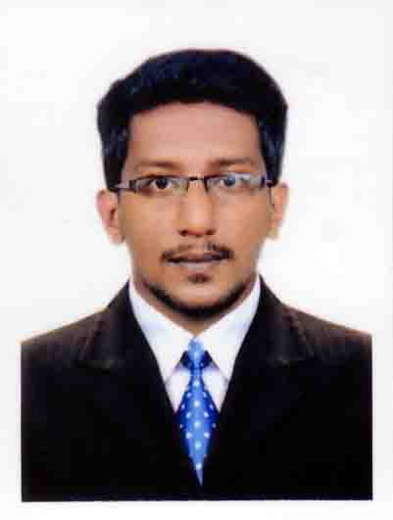

Career Objective
I am looking forward to work with a reputed organization, where I can utilize my skills to contribute the organization’s success as well as to prove myself as an asset to the organization.

Education Qualification
- Diploma in civil engineering from institution of civil engineer(India)
- Higher secondary Board of Kerala
- Central board of Kerala

Worked Experience: Three years (3 yrs)
Experience in India
1). currently working in Dale nest builders and developer pvt. Ltd, Calicut-Kerala, India as a Project coordinator.

Project Handle:

Project title : Commercial cum studio apartment
Position : project coordinator
Duration : 10.09.2013 – 25-08-2015
Location : Kerala
Architect : Prasanth associates
Client : Dale nest builders

Job responsibilities

- The project involves Supervision for all checking PCC, Water proofing, masonry for brick work, Plastering and Flooring layout. Plumbing and Electrical. Ceiling work, Structural glazing work Etc up to completion.
- Independently following with design engineer of, Architecture and Structural updated drawing for minor changes, as per site requirement needed and inspection before fixing Tiles, Gypsum etc...

- Looking after construction activities, making requisition and facilitating the arrangement procurement of construction materials and scheduling of Manpower, Scheduling of activity as per given time. Execution of civil, interior and exterior ground finish works and site supervision.
- BOQ preparation.
- Also doing company accounts works
- Dealing with Client, Material suppliers and Contactors for completion of works

2) Worked in Sketch Associate in Malappuram, Kerala, India as Draught man with Site supervisor from the period of 08-11-2012 to 30-07-2013.

Job Responsibilities

- Create design & working drawing details.
- Draught detailed multi view drawings of projects.
- Site checking & solve site problems of spot.
- Done other Responsibilities as assigned.
- Residential & commercial projects.

Professional Qualifications
- Diploma in civil engineering
- Professional in Building Animation (AutoCAD, Photoshop, 3ds MAX, Revit)

Computer skills
- Microsoft Word.
- Microsoft Excel.
- Auto CAD – 2D, 3D.
- Photoshop (rendered drawings)
- 3ds MAX.
- Revit Architectural design

Personal Strength
- Good communication skill.
- Hardworking sincerity and Honesty.
- Individual & team working capability.
- Manage development of program strategies.

Personal Details
Date of Birth : 02th Feb 1992
Nationality : Indian
Religion : Islam
Material status : Unmarried
Languages Known : English, Hindi and Malayalam

Gulfjobseeker.com CV No: 1512222

