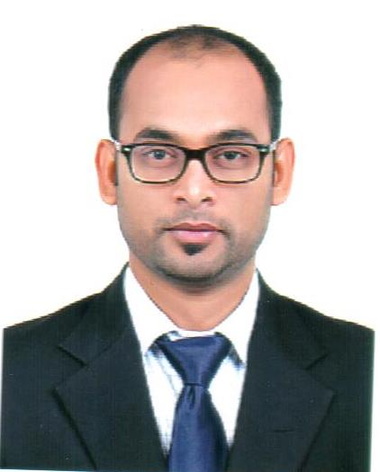

M. Hashim
Email : Hashim.252168@2freemail.com

Objectives
To obtain a responsible and challenging position in a professionally managed organization. I am looking forward to an opportunity where I can utilize my skills in contributing effectively to the growth of the organization and an opportunity for further advancement in my career.

Highlights
- Dedicated and focused, willing to take on challenging roles, tough assignments and work to tight deadlines.
- Demonstrated exceptional leadership and problem-solving abilities, highly professional, efficient planner, and excellent communication and negotiation skills.
- Confident, self-driven, self-motivated and ability to take ownership in solving issues/problems.
- Ability to maintain accounts till finalization.

Academic Qualification
Sr. No. | Education | University/College | Place | Grade/Division | Year
1. | Master of Business Administration- (MBA) | Shobhit university | Meerut, UP- India | First Div | 2014
2. | Bachelor of Commerce- (B.Com) | Deen Dayal Upadhyay Gorakhpur University | Gorakhpur- UP-India | Second Div | 2006
3. | SSC | M.S.I.I. College | Gorakhpur- UP-India | Second Div | 2003
4. | HSC | M.H.M.H.S. School | Gorakhpur- UP-India | Second Div | 2001
Certification/ License
Sr. No. | Course/ Certificate | Institute | Place | Grade | Year
1. | Certified Finance Professional- CFP | The Institute of Financial Consultant-Canada, US | Dubai-U.A.E | Passed | 2013
2. | Tally Graduate | Islamia College of Computers | Gorakhpur- UP-India | Passed | 2007

Areas of knowledge and Expertise

- Strong finance and accounting background of 08 years General accounting, Accounts payable and accounts receivable, Audit Assistant including 06 Years U.A.E Experience in Shipping Industry
- Handling All the accounts up to finalization.
- Excellent computer skills in MS Office, MS Excel and Emailing systems
- Expertise in WPS, Bank Reconciliation, Ledger Reconciliation
- MIS Reporting
- Expert in Invoicing, Online payment and banking
- Possess strong analytical and problem solving skills.
- Effective at multi-tasking and able to perform under pressure
- Handle the accounts independently.
- Expertise in SAGE, ERP and Tally Accounting Software
- Cash Flow Management
- Monitoring Payments and Receipts
- Excellent communication skills in English, Urdu and Hindi

Work Experience
Inter Seas Shipping LLC (Oct-2015 – Present)
- Preparing of invoices and payment follow-up
- Prepare various reports surrounding the metrics of the sales department: quarterly sales results, annual forecasts and account status reports
- Verifying Accounts payable, Accounts receivable, General Ledger, Bank Reconciliation, Ledger Reconciliation etc
- Preparing sales Revenue report and company expenses report
- Salary preparation and processing through WPS System
- Excellent communication skills in English, Urdu and Hindi, verbal and written both
- Extensive knowledge of keeping records, maintain the records and track the financial transactions.
- Preparation of Financial statement monthly and submitted to Head Office
- Ensure timely submission of invoices and collection of open receivable
- Preparation of Cash and receivable forecast on monthly basis
- Preparation of bank reconciliation,
- Assisting Auditors in office Auditing.
- Review the Balance Sheet accounts and Profit & loss accounts at macro level & ensure integrity of all reported financial statements
- Online payment, Banking, PDC Cheque tracking and credit revenue
- Tally ERP based reporting system.

O G F Shipping Dubai-U.A.E Accountant : (May-2014 – Sept-2015)
- Handling all the Accounts independently
- Cash Flow Management
- Strong in numbers and having remarkable logical and analytical skills
- Prepare various reports surrounding the metrics of the sales department: quarterly sales results, annual forecasts and account status reports
- Verifying A/P, A/R, General Ledger, Bank Reconciliation, Ledger Reconciliation, WPS payroll etc.
- Preparing sales Revenue report and company expenses report
- Excellent communication skills in verbal and written both
- Extensive knowledge of keeping records, maintain the records and track the financial transactions.
- Preparation of Financial statement monthly and submitted to Head Office
- Ensure timely submission of invoices and collection of open receivable
- Preparation of Cash and receivable forecast on monthly basis
- Preparation of bank reconciliation,
- Preparation of costing of the job
- MIS report, submitting to Finance Manager
- Assisting Auditors in office Auditing.
- Review the Balance Sheet accounts and Profit & loss accounts at macro level & ensure integrity of all reported financial statements
- Online payment, Banking, PDC Cheque tracking and credit revenue
- ERP based reporting system.

PENTA OCEAN SHIP MANAGEMENT Dubai-U.A.E
Accountant: (Sep-2011 – May 2014)
- Verification of Accounts Payable, Accounts Receivable.
- Served as the key person for central co-ordination of all accounting.
- MIS Reporting to Finance Manager.
- Handling petty cash.
- Banking, Online Payments, Cheque payments and PDC cheque tracking
- Checking and preparing cash/bank vouchers
- Assisting to maintain Cash flow and fund flow.
- Budget cost control.
- Maintaining balance between all with sister companies.
- Supervise of accounts team.
- Build a good relation between bankers and Vendors.
- Ensure that information flowed to and from the President.
- Daily base accounting system.
- Invoicing to customers and tracking the sales revenue
- Checking and verifying the supplier invoices and preparing the payments on time.
- Assisting Auditors in company Audit during Audit period, providing All the necessary documents to Auditors.

FOURTEEN STAR SHIPPING MANAGEMENT Ajman,U.A.E Accountant: (May 2010–Aug-2011)
- Accounts Payable and Receivable
- Bank reconciliation
- Issuance of vouchers manually & Computerized
- Handling of Petty Cash
- Vessel Charter Party Hire Accounts
- Issuance of Crew Salary Details monthly and online transfer To their Accounts
- Keeping records of Vessels Cash on Board and Provision
- Arranging Final settlement of Crews members for 14 Vessels
- Supervise Bank Transaction and Issued Cheque.
- Reporting to Finance Manager

PERSONAL PROFILE
Date of Birth : 04/Jan/1988
Nationality : Indian
Gender : Male
Marital Status : Married
Visa Status : Residence Visa
Languages known : English, Urdu & Hindi
Driving License : Issued from RTA Dubai

