ravindra.256835@2freemail.com
Ravindra
Bank Operations Management
Profile Summary

Dynamic career of 13.5 years that reflects pioneering expertise & year-on-year success in Retail Banking across banking Segment. Experienced in sales & business expansion, relationship building, selling of banking products, services and development of healthy & prolonged business relations with clients. Skilled in overall bank operations while leading Current/ Savings Accounts, Sales, Customer Services, Audit, Compliance and other major functions
Keen customer centric approach with skills in addressing client priorities and resolving escalation within TAT, thereby attaining high business & compliance score. Expertise in conducting analysis, preparing MIS reports and implementing systems to ensure operational effectiveness. Managed cross-functional & cultural teams using interactive & motivational leadership. A forward thinking person with strong communication, analytical & organizational skills

Core Competencies  Banking Operations  Back-end Operations  Revenue Management  Marketing Management  Audit Management  Audits/ Statutory Compliance  Customer Relationship Management  MIS Reporting  Team Building & Leadership  Skill Set  Collaborator  Change Agent  Motivator  Communicator  Career Timeline  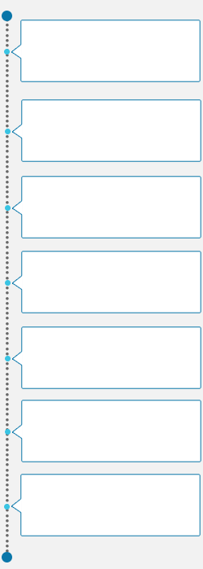  Aug’03 – Oct ’04  HBL Global Pvt. Ltd., Mumbai as Sales Executive  May’16 – Oct’17  Yes Bank Ltd., Mumbai as Branch Head  Nov’04 – Aug’05  HDFC Bank Ltd., Mumbai as Sales Executive  Sep’05 – Apr’06  Sharekhan Securities Ltd., Mumbai as Sr. Sales Officer  May’06 – Sep’07  Kotak Mahindra Bank Ltd., Mumbai as Assistant Manager – Sales  Oct’07 – Feb’13  HDFC Bank Ltd., Mumbai as Teller  Mar’13 – Apr’16  Axis Bank Ltd., Mumbai as Front Desk Officer | Academic Details  - BA (Economics) from University of Mumbai, Mumbai in 2001  Certifications:  - IRDA  - AMFI  Organizational Experience  May’16 – Oct’17 with Yes Bank Ltd., Mumbai as Branch Head  Key Result Areas:  - Spearheading sales of banking products across liabilities, assets, trade services for various customer segments through multiple channels including bank branches, outbound sales teams, relationship teams & other alternate channels  - Liaising and following-up with customers & sales teams for collecting overdue / long outstanding accounts  - Conducting competitor analysis & competency mapping for keeping updated of market trends and competitor’s moves to achieve maximum market share  - Preparing and maintaining of requisite documentation for compliance with regulatory requirements  - Generating MIS reports using Excel to ensure timely availability of business information and facilitate critical decision-making process  - Leading daily operations of bank and creating professional & customer friendly environment for the staff  - Controlling the financials of the branch and ensuring adherence with the Know Your Customer (KYC) & Anti-Money Laundering (AML) norms at all times  - Rendering advisory services to corporate & high net-worth customers on funds management while maintaining relationship with key accounts  - Coordinating with external & internal auditors and inspections & compliance  - Planning & implementing modifications in the operating procedures to optimize resource utilization & maximize productivity  Highlights:  - WON and received the appreciation certificates:  - March Dobara contest and rewarded with 3 days stay in training program  - Oscar contest and rewarded with Gold Level Qualifications  - Chalo Mahabaleshwar – 1 contest and rewarded with 2 days stay in training program  Mar’13 – Apr’16 with Axis Bank Ltd., Mumbai as Front Desk Officer  Key Result Areas:  - Managed customer centric banking operations & ensuring customer satisfaction by achieving delivery and service quality norms, reporting to management on periodical intervals  - Monitored Cash, RTGS, NEFT, Clearing, Transfers, DD, PO, Forex & other retail banking operations  - Ensured the compliance with audit updates  - Implemented the Six Sigma Quality Techniques, 5 S, Finacle Customer Relationship Management (FCRM) and Channel Migration in the banking operations through internet banking & mobile banking  - Met high revenue & corporate customers ensuring their satisfaction with the services  Highlight:  - Won Prime Panthers contest and receive the Samsung Galaxy Tab 3  Oct’07 – Feb’13 with HDFC Bank Ltd., Mumbai as Teller  Key Result Areas:  - Ensured accuracy in cash & customer transactions  - Managed cash receipts & payment including foreign currency, cash balancing & bundling  - Checked UV withdrawals & transfers over & above certain limit  - Diverted the high transacting account holders to supervisor  - Updated exchange rate board, ensured teller related audit parameters & circulars  May’06 – Sep’07 with Kotak Mahindra Bank Ltd., Mumbai as Assistant Manager – Sales  Sep’05 – Apr’06 with Sharekhan Securities Ltd., Mumbai as Sr. Sales Officer  Nov’04 – Aug’05 with HDFC Bank Ltd., Mumbai as Sales Executive  Aug’03 – Oct ’04 with HBL Global Pvt. Ltd., Mumbai as Sales Executive  Associate with HDFC Bank Ltd.
Personal Details
Date of Birth: 25th March 1981
Languages Known: English, Hindi and Marathi

