Administrator/Admin Coordinator 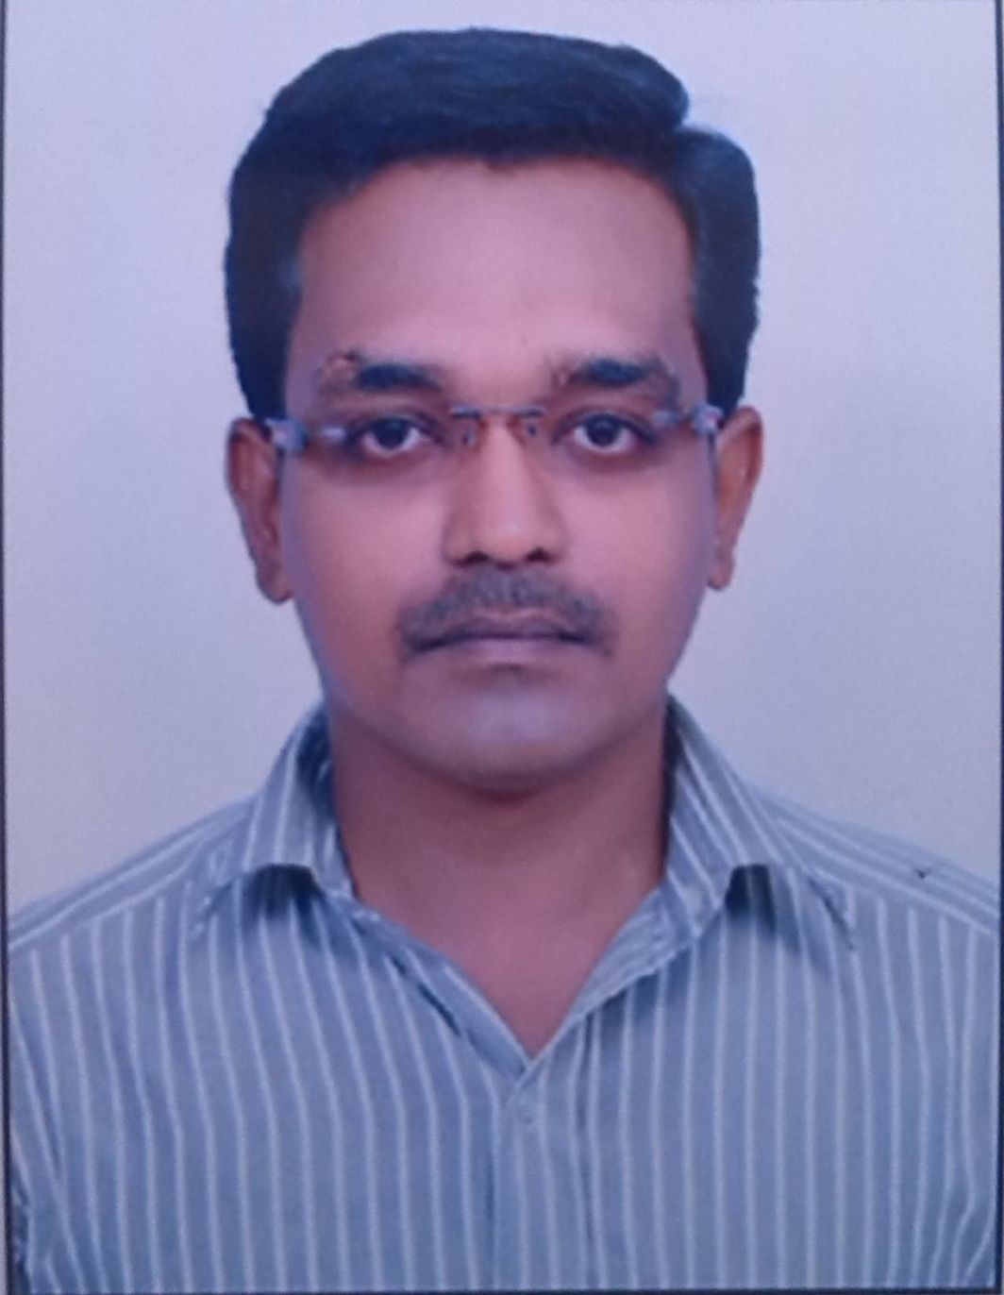

Dinesh
Sharjah
Email: dinesh.258044@2freemail.com

CAREER OBJECTIVE:

- To procure a challenging and innovative career where I can put
my knowledge and expertise to use for the organization I serve.

EDUCATIONAL QUALIFICATIONS:

Examination | School/College | Board/ University | Year Of Passing
MBA | Alagappa University | Karaikudi | 2013
BBA | Sri Aravindar Arts And Science College | Thiruavlluvar | 2009
HSC | Kamban Government Higher Secondary School | Tamil nadu State board | 2006
SSLC | Swami Vivekananda Vidyalaya High School | Tamil nadu State board | 2004

TALENT, INTEREST AND ACHIVEMENTS:

Computer Skills | - Operating Systems | - DGMDP
Areas of Interest | ▪ OFFICE WORK.
Strengths | ▪ Active and Flexible Working.

EXTRA CURRICULAR ACTIVITIES:

- Participated in state and school level drawing.
- Voluntarily serving as a NSS member in Open Unit.

KEY SKILLS:
- Good qualitative aptitude along with excellent grasping power and eagerness to learn.
- Excellent organizational skills that help in effective handling of accounts and computer knowledge
- Very good coordination and communication skills that help to establish effective communication within the company.
- Self motivation and a passion to success.

PROJECT DETAILS:

TITLE : HUMAN RESOURCE MANAGEMENT

DESCRIPTION : LABOUR WELFARE

WORK EXPERIENCE:

Sl.No | Name of Company | Designation | Experience
1 | Manakular Motors Pvt Ltd  Pondicherry | System  Adminstration | 1 Year 2 month | 2010-2011
2 | Lanson motors Pvt Ltd  Pondicherry | Adminstration  Executive | 3Year 6 month | 2012-2015

PERSONAL PROFILE:

Name : DINESH
Father’s Name : BALASUBRAMANIAN. T
Date of Birth : 08-09-1987
Nationality : Indian.
Languages known : Tamil, English.
Hobbies : Drawing, social work
Visa : Visit Visa(till 5march 2016)

Place: Signature

Date:

