RESUME

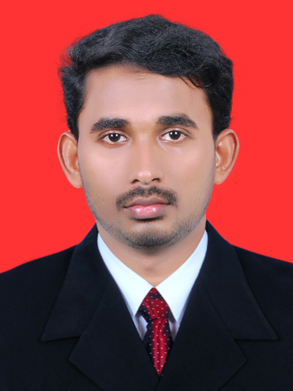
SUBHASH
Email: subhash.260702@2freemail.com

CAREER OBJECTIVE

To be part of dynamic team and effectively render my skill and commitment to an institution which aims at continuous growth and development.

WORK EXPERIENCES

- Udaya Group of Companies, India

Position: Accountant cum HR Coordinator March 2015 till January 2016.

Job Description:
- Continuous following up of outstanding receivables and Debtors.
- Invoice preparation and responsible for delivery on prompt time.
- Ensuring all cash receipts are recorded in the books at the time of collection and deposited not later than following day after collection.
- Performed Accounts Receivable, Accounts Payable and Processing Payroll Functions of the organization.
- Preparing monthly and yearly financial reports for analyze to know the growth level.
- An active role in formulating methods to improve employment policies, processes and practices as well as recommending changes to management.
- Collecting employee’s feedback, complaints and grievances. And Understanding
Employee’s needs and requirements
- Keeping employees database and employment contracts.

- Kosamattam Finance Pvt Ltd, India

Position: Accountant cum cashier [Oct 2014 - Feb 2015]

Job Description:
- Maintain Books of accounts. Make sure that denominations of the cash by hand are tally with cash book.
- Following up of outstanding receivables with debtors
- Ensuring all cash receipts are recorded in the books at the time of collection.
- Maintaining good customer relation and involve in marketing activities
- Al Arabian Leisure Tours Private Limited
Position: Accountant cum cashier [May 2012 - September 2012]

ACADEMIC QUALIFICATION

MBA (Finance) - 2014
East Point College of Engineering & Technology, Bangalore.
University: Vishweshwarya Technological University.

B.com (Co-operation) - 2012
Calicut University

HSC (Commerce) - 2009
Govt. Rajas Higher Secondary School Kottakkal
Kerala State Board

SSLC - 2007
IUHSS Parappur
Kerala State Board

PROFESSIONAL SKILLS
- Ability to work with team
- Good communication skills
- Good in Inter-personal skills
- Positive Attitude, Hard working
- Self – learning
- Easy grasping innovative ideas
- Flexible and adapt to new working environments.
- Analytical and critical thinking ability.
- An eye for detail and good observation skills.
- Handle confidential information in a discreet, professional manner.

COMPUTER PROFICIENCY AND OTHER QUALIFICATION
- MS Office
- Tally

PERSONAL DETAILS
Date of Birth :19-08-1991
Nationality :INDIAN
Gender :Male
Marital status -Single
Languages Known :English
:Hindi
:Malayalam

DECLARATION

I declare that the information mentioned above is correct and complete to the best of my knowledge and belief.

Date: - Your’s sincerely,
Place: -

