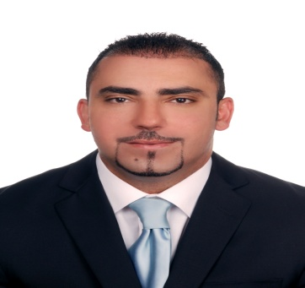
Mohammad Subhi
Mob: 0097150-8790672
Nationality: Jordanian
B.O.D 25-May-1980
Email: m7md_subhi@hotmail.com

PROFILE
A highly motivated, results orientated manager with a strong background in purchasing management capable of leading high performance teams and successfully increasing efficiency and productivity whilst reducing costs. With over 9 years experience in UAE and successfully keeping a level head at all times, and also delivers innovative new solutions to challenges.

CAREER SUMMARY

- Procurement & contracts specialist from 2014 till Now in Abu Dhabi Government (Quality & conformity council)

- Ensure that the procurement strategies and policies are implemented effectively and efficiently.
- Preparing RFQ in order to obtain quotations either by tendering or inquiry after receiving the requisitions from end users.
- Preparing the financial evaluation after receiving the technical evaluation from the requester in order to prepare the final evaluation.
- creating purchase order using Oracle system(ERP) and get it signed from the authorized person and send it to vendor in order to acknowledge receiving by signing and stamping the purchase order.
- Preparing the annual maintenance contract and blanket agreement for consumable items.
- Create items receiving for each purchase order and create releasing for contracts and blanket agreements.
- Negotiate the best price and under the most favorable terms for all contracted parties

- Purchasing Manager from 2007 till 2014 in Interiors Furniture (Easa Saleh Al Gurg Group)
- Experience in various facets of purchasing materials from local and foreign suppliers.
- Experience with inviting and allotting new vendors.
- High negotiation skills of reducing the cost .
- Experience with implementing systems of inventory management avoiding over-stocking or wastage.
- Coordinate with finance department for releasing payments on time.
- Developing stock study reports of materials for top management in order to provide them the feedback of fast and slow moving items.
- Controlling all yearly maintenance contracts.
- Excellent experience of using SAP system(Creating FPO, LPO, releasing, creating codes for materials, entering selling price, stock study for items, daily delivery schedule, LTO, LTI and inbound delivery.
- Controlling all the IT issues and assets.

- Computer instructor from 2005 till 2007 in Development institute
- Microsoft office and operating system trainer.
- Computers maintenance trainer.

EDUCATION & TRAINING
- 2004 Bachelor of Computer Science University of Petra (Jordan)
- 2005 Oracle 9i, Developer 10g (SQL,PL/SQL, Forms, Reports) at ITCC training Institute (Jordan)
- 2006 ICDL certificate Ministry of Education (Dubai)
- 2007 SAP software system Training (Dubai)
- 2010 Purchase Management Training (Dubai)
- 2012 Leadership Development Training (Dubai)

LANGUAGES
- Arabic: Mother language.
- English: Excellent in reading, writing and speaking.

INTERSETS
Web surfing, and learning new technologies.

