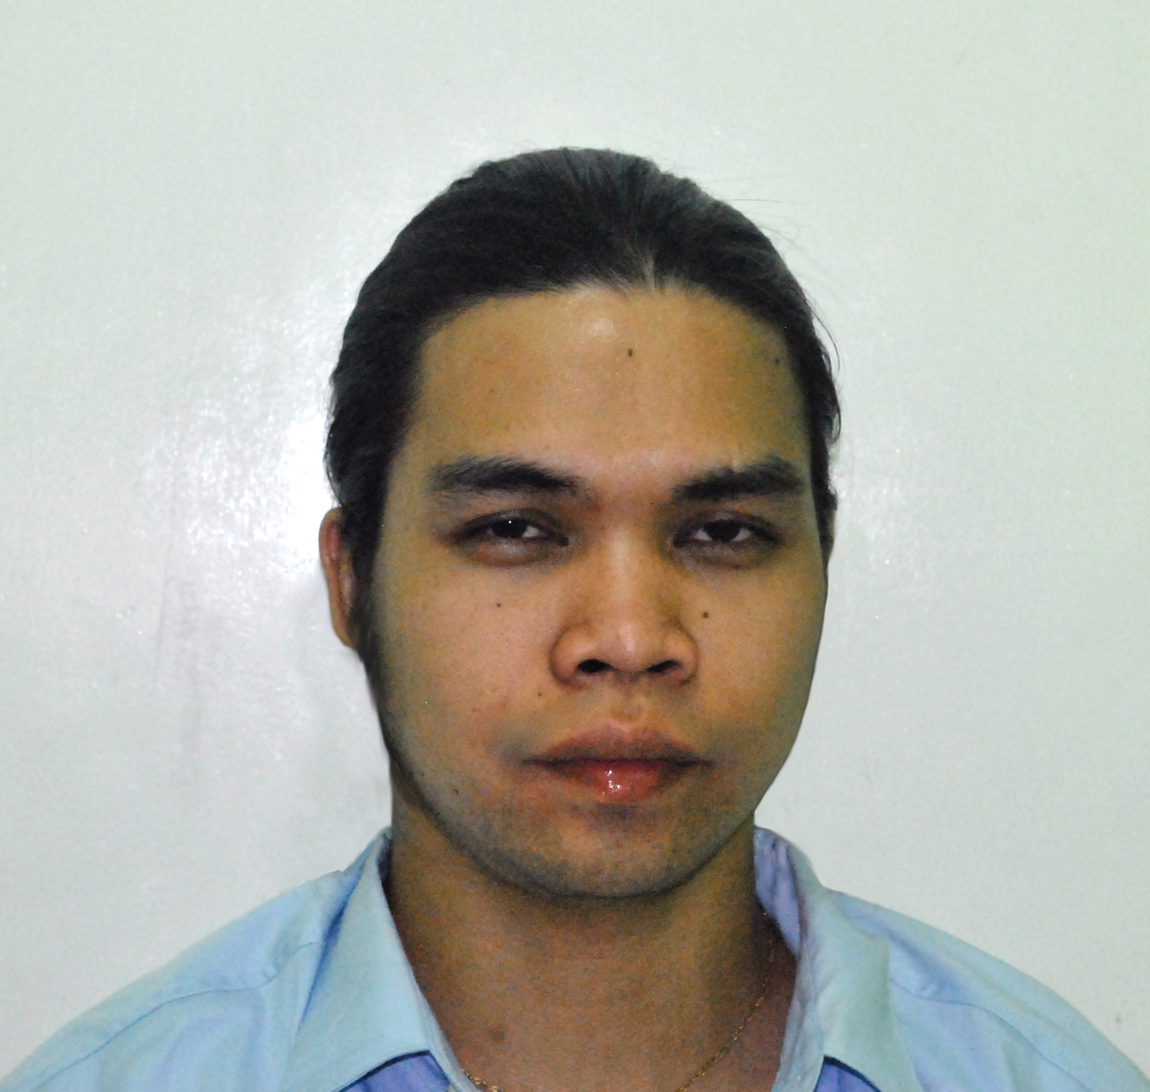
CV NO: 1565712

Whatsapp Mobile: +971504753686 Phone +97143970978 E-mail: gulfjobseeker@gmail.com

MICHAEL

OBJECTIVES To seek for better career advancement opportunities and exposure
To be part of a progressive company that would utilize my skills

EDUCATION Bachelor of Science in Computer Science
Holy Angel University
Sto. Rosario St., Angeles city, PH
2000-2005

Don Teodoro V Santos Institute
Mabalacat City, Pampanga, PH
1996 – 2000

Mabiga Elementary School
Mabiga, Mabalacat City, Pampanga, PH
1990 – 1996

TRAINING PROGRAMS

PAGSO 6TH National Convention, Gaining New Heights in Gov't. Service
Baguio City, PH
May 18-21, 2011

Recent Developments in Public Administration & RA 9184
Puerto Princesa, Palawan, PH
August 24-26, 2011

Issues on Property & Supply Management System, Internal Control System
w/ updates on RA 9184
Tagbilaran City, Bohol, PH
September 13-15, 2012

Crisis Management: Responding to Natural & Man-Made Disaster
Angeles City, PH
March 31, 2012

Phil. Association of Gen. Services Officers Inc. (PAGSO)
Bagiuo City, PH
June 6 – 8, 2013

Department of the Interior & Local Government (DILG)
Skills enhancement training towards LGU website information empowerment (2nd wave) entitled “Bridging the Digital Divide in Local Governments”
Baguio City, PH
Oct. 1-3, 2014

LGU Mabalacat City Gender Sensitivity Training (GST)
Angeles City, Pampanga, PH
December 4, 2015

EMPLOYMENT EXPERIENCE

Administrative Assistant II
City General Services Office
City Government of Mabalacat
Mabalacat City, Pampanga
February 2009 – February 2016

- Provide general administrative support to the Head Department and staff team.
- Provides work direction to clerical and technical staff, directly or through supervisors or lead workers.
- Assists in the coordination, supervision, and completion of special projects, as appropriate.
- Researches, negotiates and monitors contracts and agreements with outside suppliers, service providers, leasing agents and others.
- Ordering of equipment, materials and office supplies.
- Undertake and assist in the recording and processing of invoices, receipts and payments as required and instructed.
- Administer the petty cash system and ensure appropriate record keeping.
- Prepare contracts for suppliers as advised.
- Assist in matters relating to marketing and publicity for the Company
- Provide support for the arts programme/projects including assisting with administration of project work where appropriate and when agreed.
- Collation and distribution of minutes, reports and other documents.
- Dealing with incoming and outgoing mail and general emails.
- Responds to requests from the public and other governmental and private entities for organizational, technical, operational and administrative information about the division.
- Develop and carry out an efficient documentation and filing system in the organization.
- Performs miscellaneous job-related duties as assigned.
- General word processing. Filing, copying and faxing.
- Produce reports, presentations and briefs as and when required.

Administrative Assistant
City General Services Office
City Government of Mabalacat
Mabalacat City, Pampanga
June 2005 – February 2009

- Assisting in the canvass, procurement, and distribution of supplies and materials
- Assisting in the preparation of payrolls, biddings, and other related matters.
- Assisting in the preparation of various documents of the Municipality.
- Assisting in other clerical works.
- Technical Support (PC Troubleshooting, Hardware, and Networking)

On-the-Job Training Program
Unity Bank (Angeles Branch)
Angeles City
January – March 2005

- Assisting in encoding, posting, and sorting of bank account.

SKILLS

- Strong interpersonal and communication skills and the ability to work effectively with a wide range of constituencies in a diverse community.
- Ability to gather data, compiles information, and prepare reports.
- Records maintenance skills.
- Ability to use independent judgment and to manage and impart confidential information.
- Ability to analyze and solve problems.
- Ability to plan, develops, and coordinates multiple projects.
- Skill in organizing resources and establishing priorities.
- Demonstrated ability to maintain confidentiality.
- Knowledge of office management principles and procedures.
- Ability to make administrative and procedural decisions and judgments on sensitive, confidential issues.
- Skills in the use of database management, word processing, spreadsheet, and/or presentation software.
- Ability to foster a cooperative work environment.
- Proven office organizational and file management skills, strong ability to multi-task
- Understanding of computer software programs and excellent IT knowledge and skills including networking, PC troubleshooting, databases, email, Adobe Photoshop etc.
- An ability to prioritize, plan and organize work in a busy environment.
- Basic Photography

STRENGTHS

- Willingness to learn new things, Innovative, Creative, Persuasive, Multi-tasker, Self-directed, Result-driven, Goal-oriented and Aggressive and Team player
- Can interact and cooperate well with office heads and fellow workers
- Can drive and has a International Non-Professional driver’s license

PERSONAL PROFILE

Name: Michael Nationality: Filipino
Gender: Male Civil Status: Single
Date of Birth: April 20, 1983 Height: 5’7”
Weight: 120 lbs.

References available on request.

I HEREBY CERTIFY that the foregoing information are true and correct in the best
of my knowledge and ability

MICHAEL
Applicant

