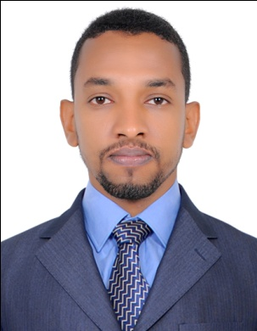
Gosay

Email:: Gosay.261727@2freemail.com
Computer & Electronic System Engineer looking forward to work at a good company with the proper environment to demonstrate my skills and increase my knowledge and level of expertise.
Personal Information:
- Gender: Male
- Nationality: Sudanese
- Marital status: Single
- Date of Birth: 13/11/ 1990
- Place of Birth: Khartoum - Omdurman
- Religion: Muslim

Qualifications:
4th of Dec 2014
- Has been awarded computer Architecture and Networking MSc
From University of Khartoum Elctronic Engineering Department.
28th of August 2012:
- B.Sc. (Honor) in Computer & Electronic System Engineering.
University of Science and Technology Faculty of Engineering
Sudan.

19th of March 2007:
- Sudan Secondary School Certificate:From Al-Halfaya Al-Namozajya Secondary School.

Technical skills:

- Good knowledge in MS Office especially MS Word, MS Excel,MS Power Point and MS Access.
- Good knowledge with programing languages specialy C++ and MATLab.
- Good knowledge in linux .

Courses & Training:
1st of Jan until 24th of May 2013
- Worked as A computer and network Engineer at
Africa City of Technology.
8th of Jan 2013 until 18th of Feb 2013
- Took a course at Computer Netwoorks Desgin and has been awarded a diploma from SUDACAD(sudatel telecommunication academy).
18th of Novuntil the 6th of Dec 2012:
- Took a training course on HCP-Grid Management Software
From Africa City of Technology.
12th to 14th of Dec 2012
- Took a training course on Linux Oparating System
From Africa City of Technology.

Communication Skills:

- Team player & Team leader.
- Ability to adapt to new environments.
- Well organized.
- Highly motivated.

languages:
- Arabic: Native
- English: Good

