Curriculum Vitae

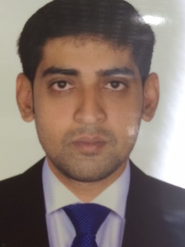

Raza
Contact : C/o 971505891826
Email: raza.27347@2freemail.com

Objective:

I intend to use my professional expertise in the field along with my knowledge towards expanding the customer base of the organization, apart from ensuring optimum customer satisfaction for the existing customer. I seek to offer my salesmanship skills, along with my extensive experience in the field, towards the performance of my duties and consequently toward the growth of the organization.

Experience:

Currently working with Popley Jewelers Starting from Dec 2011 to Aug 2017, As a senior sales executive.

Products: Gold and Diamonds Accessories

- Responsible as a shop in charge and works towards achieving sales targets as set by the management.

- Developed strong relationships with installed base customer for on-going business.

- Prepare daily sales report.

- Being interactive and sensitive to the needs of the sales team in the terms of handling queries, providing feedbacks and striking a balance between risk, controls and services.

- Close the deal with satisfaction of the customer requirement.

- Check requirement of the customer and give them demonstration on the base of their requirement.

- In charge of merchandise with right and elegant manner.

- Planning to achieve monthly target.

Educational Qualification:

- Intermediate from St.Georges College Hyderabad India.

- Matriculation from Government Boys High School Hyderabad India.

Computer Skills/ Operating Skills:

Windows XP, Windows 2000 Professional, Windows Vista, and Windows 7

Personal Information:

Date of Birth : 5th Jan 1985
Marital Status : Married
Nationality : Indian
Language Know : English, Hindi & Urdu
Visa Status : Visit Visa Expires on 20 April 2018.

