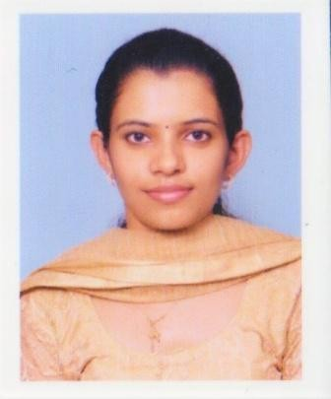
MARIAM

C/o-Phone: +971501685421
Email: mariam.262683@2freemail.com
Currently on visiting visa in UAE.

Date of Birth: 23-01-1992
Nationality: Indian

OBJECTIVE
To obtain a position in an engineering firm, preferably in Electrical Design & Estimation Industry, to implement and improve my technical creativity and professional skills, while delivering the desired output to the firm.

CAREER HISTORY
- From December 2016 – December 2017

Working as Electrical Engineer at Turner and Miller Technologies PVT Limited,

Trivandrum (Head office at Al Qusais, Dubai)
MEP Engineering contractors

Key Responsibilities and Tasks Performed:
- Estimation and Tendering for various projects in UAE:
- Estimation of quantities from the Tender drawings in comparison with BOQ & Specifications.
- Enquiry preparation for pricing of estimated items.
- Preparation and pricing of BOQ.
- Purchase order preparation for materials needed.

From September 2015 – December 2016 110kV Substation Ayarkunnam
  - Assistant Engineer on Contract basis(Operator) Key Responsibilities and Tasks Performed:
- Daily operations and assisting in the maintenance works of 110kV and 11kV feeders, Two transformers of 10/12.5MVA, Vacuum circuit breakers & SF6 circuit breakers, Current transformers, Potential transformers, Lightening arrestor.
- Monitoring of both 110kV & 11kV panels.

From March 2015 – September 2015 110kV Substation Pampady
  - Graduate Apprentice Trainee
Key Responsibilities and Tasks Performed:
- Daily operations and assisting in the maintenance works of 110kV and 11kV feeders, Two transformers of 10/12.5MVA, Vacuum circuit breakers & SF6 circuit breakers, Current transformers, Potential transformers, Lightening arrestor.
- Assisted during the up gradation work of substation from 66kV to 110kV

EDUCATIONAL BACKGROUND
Year | Board/University | Course Completed | %
2010-2014 | Cochin University of Science and Technology | B-Tech in Electrical And Electronics | 67.9%
2008-2010 | Board of Higher Secondary, Kerala | Plus Two | 81.16%
2007-2008 | State Board of Kerala | SSLC | 85%

SKILLS
Computer & Software:
-Auto-CAD
-MS-Office
Certificate Course:
-Electrical Designing and Drafting Course includes:
LV design and selection
Transformer, Generator selection,
Lighting design using dialux, Fire Alarm, CCTV

Professional Highlights
- Ability to Work as a team
- Enthusiastic to familiarize with new technologies and learning from others.
- Time Management

LANGUAGE PROFICIENCY

To Speak: | English, Malayalam
To Write: | English, Hindi, Malayalam

DECLARATION
The above-furnished information is true to the best of my knowledge and belief and can be supported by relevant documents as required.

