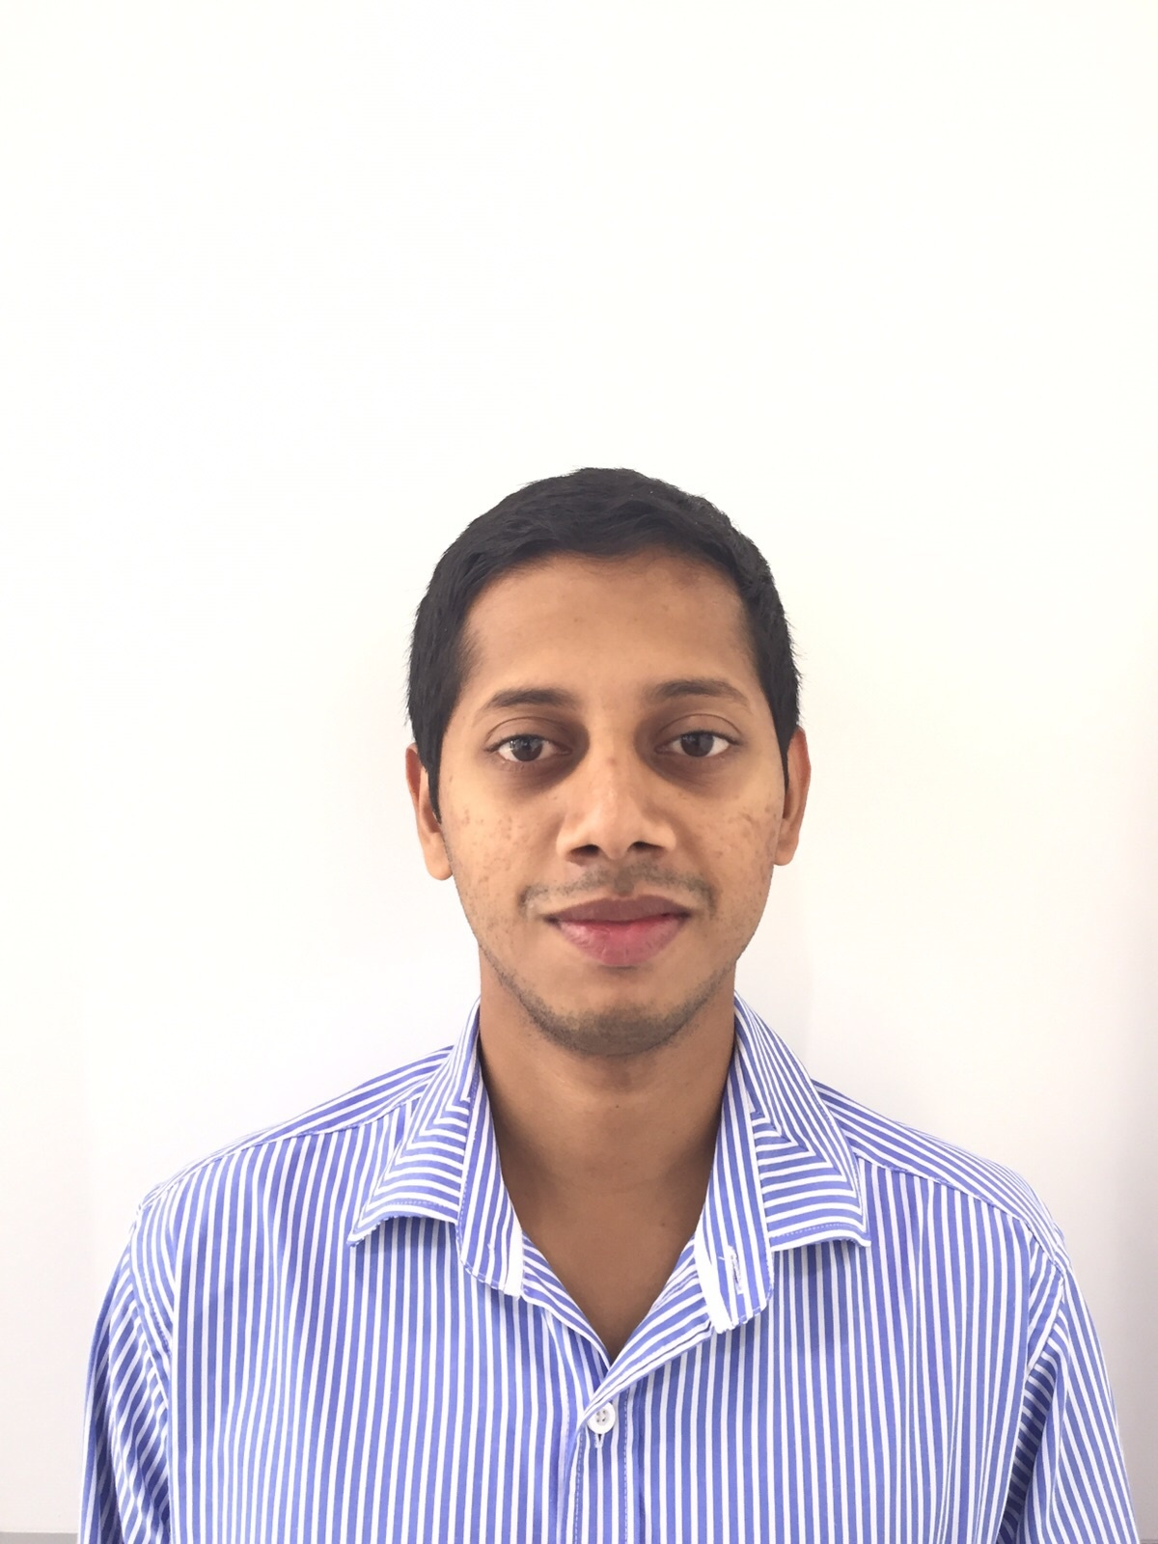

AARON
Background : B.E (MECHANICAL) EMAIL: aaron.264633@2freemail.com

OBJECTIVE
To work in challenging & responsible position in a dynamically progressing organization. this will give scope to apply my skills knowledge and to constantly grow with the company. I am eager to contribute my creativity and hard work towards the success of your company and to the growth of the fast developing field.

QUALIFICATIONS

DEGREE/ DIPLOMA | YEAR OF PASSING | SCHOOL /COLLEGE | BOARD /UNIVERSITY
BE(MECH) | 2006-2010 | St Joseph Engineering College, Mangalore-28 | Visveswaraya Technological University
2nd PUC | 2005-2006 | St Aloysius PU College, Mangalore-3 | Karnataka Pre University Board
SSLC | 2003-2004 | St Aloysius High school,  Mangalore-3 | Karnataka Secondary Education  Examination Board

PROFESSIONAL SUMMARY

Highly focused and creative Mechanical Sales engineer with superb records in sales and customer satisfaction. Innovative salesman with a fresh and wholesome approach. Adapt at functioning well independently or as member of a sales team.

EXPERIENCE DETAILS
Organisation | Alfairuz Trading & Contracting Co.LLC (www.alfairuzoman.com)  Authorized dealers of OMAN for  - HITACHI- excavator & wheel loaders  - ASTRA TRUCKS  - CIFA-transit mixers  - NPK HAMERS  - FURUKAWA-rock drills &hammers  - SANDVIK – crushers& screeners  - SPEKO-asphalt plant  - TEREX – cranes, backhoe loader, tower light  - GENIE – aerial working platforms  - YALE - forklifts  - SCHWING STETTER- concrete pumps& cement batching plants  - SNOWKEY – chiller plants  - OMEGA – fork lifts  - ZENITH-block making machine  - AMMANN-Road roller
Designation | Sales Engineer - SPARE PARTS
Duration | March 2014 – Till Date
Responsibilities | SALES,PLANNING&LOGISTICS  - Researched and communicated with prospective clientele – Gave product presentations to customers and company staff regularly.  - Learned client and system needs by working closely with the company sales team and engineers, collaborating promotions and customer support.  - Designed and implemented sales plans, identified sale possibilities and consistently met the sales goals as planned.  - Recommended various improved materials or machinery to customers and clients by showing how these changes and improvements would lower costs and improve performance.  - Managing front counter, retail and wholesale business enhancing sales through emails and telephonic conversation with customers, preparing quotation and follow up and competitive price quoting for wholesale customers  - Distribution management.  - Quality assurance.  - Inventory control process.  - Transportation/material handling.  - Material & resources planning.

EXPERIENCE DETAILS

Organisation | Aditi Engineering Corporation & Anirudh Engineering Components.  - Authorized dealers for ATLAS COPCO COMPRESSOR &DEMAG CRANE respectively.
Designation | Sales ,Logistic and Erection Engineer
Duration | April 2013 – March 2014
Responsibilities | SALES ,LOGISTICS,PLANNING&ERECTION  - Researched and communicated with prospective clientele – Gave product presentations to customers and company staff regularly.  - Learned client and system needs by working closely with the company sales team and engineers, collaborating promotions and customer support.  - Designed and implemented sales plans, identified sale possibilities and consistently met the sales goals as planned.  - Recommended various improved materials or machinery to customers and clients by showing how these changes and improvements would lower costs and improve performance.  - Distribution management.  - Quality assurance.  - Inventory control process.  - Transportation/material handling.  ERECTION  - Coordination with consultant, main contractor.  - Arranging and forecasting of manpower, materials, tools and machinery as per the requirement.  - Strict follow up and chase the site staff to complete the project.  - Ensuring safety and quality as per company requirements.  - Ensuring correct reporting of project and status to top management.

EXPERIENCE DETAILS

Organization | Apex Honda Ltd, Mumbai  - Authorized dealer for Honda, Audi cars, most largest service company, known as Aadya Motor Company .  - Top class servicing facilities, 2 branches in Mumbai.  - Specialized manpower for servicing of Honda and Audi cars  Prompt Service.
Designation | Marketing executive
Duration | March 2012-March 2013
Responsibilities | - Conducting Service Camps, display events and creating alertness to the customer regarding service of the car.  - Continuous follow of highly dissatisfied customer and resolving their concerns regarding the quality of service .  - Direct Interaction with the customers and Corporate customers.  - Developing strategies & customized solutions to selected corporate companies.  - Explore market opportunity for bulk deals.

TECHNICAL KNOWLEGE

- Software: Microsoft Office tools

- Well versed with Browsing Techniques

- Designing Software: Solid Edge(v.18), ANSYS 11.0, CNC TRAIN

- SAP(system ,applications ,products in data processing)

MY STRENGTH & ACHIEVEMENTS
- Good team player and ability to lead a team
- Positive approach

CO-CURRICULAR ACTIVITIES
❖ Attended the INDUSTRIAL TRAINING at MANGALORE CHEMICAL FERTILIZER LIMITED.

❖ Singing, dancing.

❖ Interested in sports such as ,cricket ,volleyball ,basketball and Football.

❖ Active member of AICUF.

PERSONAL DETAILS
GENDER : Male
DATE OF BIRTH : 26th Feb 1988
NATIONALITY : Indian
Languages Known : English, Hindi, Kannada, tulu , Konkani,Marathi&Arabic
GCC Driving license:

I declare that the information given above is true to the best of my knowledge.

----------------------------------
(AARON)

