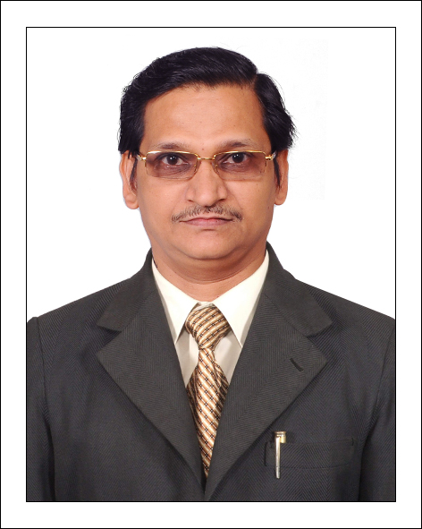 Arunkumar Pathangay Subramaniarao

Contact Info
Email : arunkumar.268575@2freemail.com

Objective

To secure an Outstanding high position where my skills in the areas of Accounts/Finance and any such related fields can be utilized by a progressive and innovative company, offering long term prospects, whereby hard work, dedication and ability to acquire new skills will provide me and the company an opportunity for growth based on performance, initiative and mutual passion for success.
My areas of expertise that may be of interest to you include:
- Bookkeeping & Accounting
- Finalizing Accounts and Audit
- Preparing Reconciliations of Bank Statement
- Fund Management
- Internal External Auditor Liaison
- Accounts Payable
- Accounts Receivable
I believe my level of expertise is appropriate for the role of Accountant within your organization.

Work
04-2015  –  03-2016 | Sr. Accountant  Waterline Freight Solutions, Dubai, UAE  Complete Accounts handling up to finalization.
09. 2009  –  03.2015 | Sr. Accountant  Advanced Electromechanical Trading LLC, Abu Dhabi, UAE  Managing the Cash Flow of the Group by liaising with customers promptly and working closely with Project heads / Senior Managers.  - Ensuring timely receipts of receivables  - Evaluating the need for the financing and arranging the credit facilities in terms of TR, LC, ABG/PBGs, etc. from various bankers  - Managing all kinds of Bank Guarantees including the timely return of BGs to bank upon completion of Project or completion of Defects liability Period  - Project wise & overall Receivables & Payables Management.  Bank:  - Complete Maintenance of Cheques issue on due dates and receipt and recording transaction in system package.  - Periodic monthly Bank Reconciliation for all Banks of all six group companies.  - Keeping track of all Bank Balances of group companies on daily basis and updating to the management  - Preparing of Fund flow statement on daily basis and updating to the management  - Going to Bank and interacting with Banks regarding LC’s, Advance Bank Guarantee, Performance Bank Guarantee, Security Bond Guarantee, depositing the cheques etc  - To maintain all bank transaction in a good traceable manner filing  - Liason with bank for opening of Letter of Credit and Receiving of Letter of credit and all bank related transactions  Cash:  - To maintain the petty cash of six group companies in Excel and in system package  - Cash tallying every day with the books and in physical  - Receiving and making the cash payments to staff, directors and others after approval from management  - To maintain all cash transaction in a good traceable manner filing  Sales:  - Preparing of Invoices of all three group companies after receiving concurrence from concerned project managers and from the management and arranging dispatch of invoices along with delivery notes, purchase orders, reports if any, to the customers.  - Going to Customer’s place for LC Documents authentication, payment receipts, any queries or dispute to settle with the customers regarding payments, invoices, delivery of materials  - Periodical Customers reconciliation with the books and customer’s statement of account  - Follow ups for payment from Customers on due dates  - To maintain all customers transaction in a good traceable manner filing  Purchases:  - Checking of Purchased orders raised, by order numbers, dates, place of delivery, currency, materials, rate with vendor’s quotation, material requisition raised by the concerned project managers  - Receiving of Purchase invoices, checking with our Purchase order, delivery notes along with the concerned received materials person signature  - Booking the purchase invoices in system package once received the invoice from vendor after verification on day to day basis  - Cheque payments to Vendors upon verification of our purchase order, Vendor’s Quotation and material requisition and materials delivery note properly received by the concerned site in charge  - Periodical Vendors reconciliation with the books and vendor’s statement of account  - To maintain all purchase transaction in a good traceable manner filing  Auditing:  - Scrutinizing each and every transaction of book of accounts in the system and finding of errors if any, and rectifying the transaction by proper journals as per the instruction of Auditor, coordinating for all group companies auditing
05. 2007  –  08. 2009 | Accountant  Compact Systems Pvt. Ltd., Chennai, India  Complete Branch Accounting handling up to finalization.

09.1996  –  04.2007 | Accountant  Vam Organic Chemicals Ltd., Chennai, India  Complete Branch Accounting handling.
10. 1991  –  05.1996 | Accounts Assistant  Dynamic Consultants, Chennai, India  Assisting to Accounts Manager in all aspects of Accounts.
 | Work Experience – Totally 25 Years [About 7 years in UAE]

Education
1991 | Bachelor of Commerce  University of Madras

Diploma
Diploma in Computer Application PGDCA
Higher Grade Examination in English Type Writing

Skills

Ability to handle multiple tasks and solve Accounts queries efficiently.
Ability to build and maintain good relation with co-staff, customers & vendors
Ability to work accurately in stressful circumstances.
Ability to learn any software and skill in short time span.
Basic knowledge of Microsoft Office (Excel, Word, Outlook)

Personal Info

Date of Birth | 6th March 1970
Marital Status | Married
Nationality | Indian
Visa Status | Visit Visa, Expiry : 21st October 2016
Languages Known | English, Tamil, Marati-Mother Tongue

General Info

- Working methods and habits followed as per the company rules and regulations
- Making full efforts in the job and consistent meeting the requirement of the position and with the satisfaction of Superiors.
- Maintaining good attitude towards superiors and sub-ordinates
- Punctuality maintaining strictly as per the company rules and regulations
- Self developing to the fullest satisfaction of the management
- Trying hard for the potential growth in the position
- Competing to the level of good international standard

