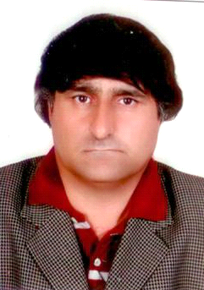noor
E-mail : noor.268598@2freemail.com

CAREER OBJECTIVE
Seeking A position where I can maximize my management skills, quality assurance, program development, and training experience that utilizes my skills and enables me to make a positive contribution to the company.
MAJOR STRENTH:

- Hardworking and result oriented
- Can train and motivate junior staff,
- Ability to meet deadlines and can work under pressure with less supervision
- Highly self-motivated, ambitious and dedicated in providing high standards of service
- Fast learner & self-motivated.
WORK EXPERIENCe
- Worked as Sales Promotion Officer in MACTER INTERNATIONAL PHARMACEUTICAL
2003 — 2004

- Worked as Sales Promotion Officer in AMSON VACCINE AND PHARMA (PVT) LTD
2004 — 2006

- Worked as dispense more then a year.

- Worked as Security Guard in G 4 S Company at Dubai base from 31-5-2007 to
01-01-2008

- Worked as Business Development Executive in R.B.S THE ROYAL BANK of Scotland.
Since 31-03-2008 to October 2011

- Worked as Tele Marketing Executive with ADCB Bank in Dubai UAE.
FROM Oct 2011 To 2nd November 2015

EDUCATIONAL ATTAINMENT
- S.S.C : 2nd Div Yr 1990

- F.Sc (pre medical) : 2nd Div Yr 1992

- B.Sc (pre medical) : 2nd div Yr 1996

- Dispenser Certificate : Yr 1995 Yr 1996

COMPUTER SKILLS
- Medical transcription certificate from "COMSAT ISLAMABAD" Pakistan

EXTRA SKILL
- A responsible and good leader
- Leadership capabilities
- Hardworking and can work under pressure
- Excellent written and verbal communication skills
- Ensuring high levels of customer satisfaction.
- Flexible, open to ideas and wills to learn
- Extensive commercial awareness.
- Motivating employees to do better.
- People Management.
- Updating work colleagues on business performance, new initiatives and related issues.
- Providing focus and direction to subordinates.
PERSONAL REFERENCE
Father’s Name : Arab Khan
Date Of Birth : 12-04-1973
Nationality : PAKISTANI
Civil Status : Single
Sex : Male
Visa Status : Tourist Visa

LANGUAGES SKILLS
- English Read, write and Conversation Good
- URDU/HINDI Read, write and Conversation Good

DECLARATION
I hereby certify that the above information are true and correct to the best of my knowledge and belief.

CHARACTER REFERENCE
WILL BE PROVIDED ON DEMAND

