SANDYA
SANDYA.268667@2freemail.com
HR Assistant with 4 years of experience
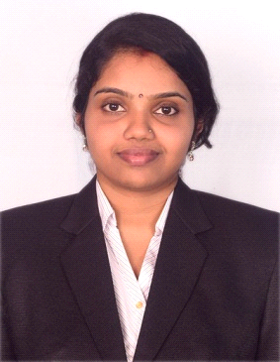

Career Objectives :
Human Resources Management Professional seeking opportunities wherein my experience will enhance a company’s overall strategic plan and direction.

Work History:
Worked as a HR Assistant cum Admin staff in HR Department in YENEPOYA UNIVERSITY, Mangalore, India from 01.06.2010 to 12.04.2014 (4 years).
Responsibilities:
- Verifying and maintaining the leave records of the staff.
- Preparing the appointment orders and confirmation orders
- Preparing experience letters, relieving orders, office orders, Memo, probationary orders, certificates, extension orders.
- Permission letters for attending conferences, meetings and issuing circulars.
- Preparing note and sending it to Registrar and Director for their approval.
- Taking the print out of salary slip as soon as the salary is paid to the employees
- Filling up the nomination forms once the candidate is taken on rolls and sending a copy it to the respective department for record purpose.
- Informing the candidates date, time and venue for interview.
- Preparing documents for interview
- Assisting in verification and Comparison of payroll work
- Feeding the data to the salary software and submitting them with identity codes for biometric purpose

Academic Qualification:
- Post Graduation (Master of Social Work) with HR Specialization from Mangalore University India with 1st class in the year 2009.
- Graduation (Economics Political Science English Optional) from Mangalore University India with 1st class in the year 2007.
- Pre- University Education Board with 1st class in the year 2004.
- SSLC from Karnataka Secondary Education Examination Board with 1st class in the year 2002.
IT Skills:
- MS – Office, Windows
- Internet & Multimedia.
PERSONAL DETAILS:

Date of Birth | 03/05/1986
Nationality | Indian
Marital Status | Married
Passport No
Visa Status | Husband Visa
Languages Known | English, Hindi

DECLARATION:

I hereby declare that the information given above is true and correct to the
best of my knowledge and belief

