CURRICULUM VITAE
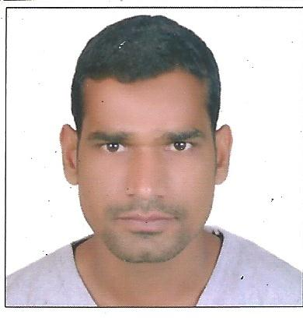
ABDUL
ABDUL.271071@2freemail.com

POSITON APPLID FOR: -OFFICE ASSISTANT

Career Objective:-
To work in an environment which offers a good opportunity to share my Knowledge and skills with others and participate My Self and work towards for a complete satisfaction of the company.

Personal Detail:-
Nationality : India
Date of Birth : 01-01-1987
Gender : Male
Marital Status : Unmarried
Languages Known : English, Hindi

Educational Qualification:-

- High School from U.P Board in 2004 (56%)
- Intermediate from U.P Board in 2006 (57%)
- B.A Passed from Lord Buddha P.G College U.P in 2010 (51%)

Professional Qualification
- Tally 9.0
- SIIT Institute Nanpara
Total Experience:-

- Worked as a Sales Executive with Dabour India Ltd in India from 3 Years.
- Worked as aAsset Tracker CleancoCompany in Abu Dhabi from 3 Year.

Declaration:-

I hereby declare that the above mentioned statement is correct& true to the best of my knowledge & belief.

