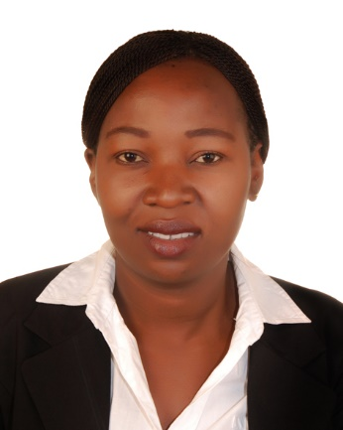
VIMBAI

VIMBAI.271539@2freemail.com
GEOGRAPHY/SOCIAL STUDIES TEACHER

PERSONAL PROFILE
- A confident, enthusiastic and hardworking geography teacher who is able to teach students across the school going age range, whilst at the same time encouraging them to develop their skills, knowledge and confidence.
- Possessing extensive knowledge of contemporary teaching methods and having immense subject knowledge, enthusiasm and charisma as well as a genuine interest in educating others.
EXPERIENCE
Ministry of Education -Zimbabwe Geography/Social Studies teacher
Mwanza Secondary School January (2009)-December (2015)
RESPONSIBILITIES
- Plan, evaluate and grade students' class work, assignments, and papers
- Compile, administer, and grade examinations, or assign this work to others.
- Initiate, facilitate, and moderate classroom discussions.
- Maintain student attendance records, grades, and other required records.
- Prepare course materials such as syllabi, homework assignments, and handouts
- Keep abreast of developments in their field by reading current literature, talking with colleagues, and participating in professional conferences.
- Facilitating community projects like putting fire guards and gully reclamation
Queen Elizabeth High School Student teacher (Jan-April 2008)
PROFESSIONAL QUALIFICATIONS
- Bindura University of Science Education (2011-2014)
Bachelor of Science Honors Degree in Education-Geography
- University of Zimbabwe
Diploma in Education-Geography Zimbabwe

- Zimbabwe Handball Federation
Handball coaching
ACADEMIC QUALIFICATIONS
Advanced level 2003 to 2004 St David’s Girls High Bonda
Three subjects passed (GEOGRAPHY, MANAGEMENT OF BUSINESS AND ACCOUNTING)
Ordinary level 1999 to 2002 St David’s Girls High Bonda
9 subjects passed (INCLUSIVE OF MATHEMATICS, ENGLISH AND PHYSICAL SCIENCE)
Extracurricular Handball Coach
Athletics coach
Official for Rugby Festival Game
Basketball player
Participated at the Water and Sanitation Launch by Dr Parirenyatwa in 2008
Activities Peer education (Guidance and Counselling)
Educational field trips

REFEREES UPON REQUEST

