NAME; MAHESHWARI 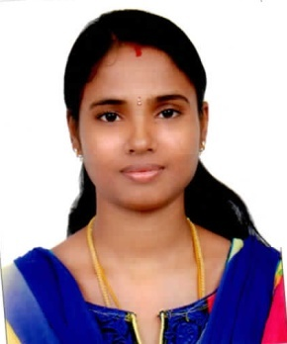
Job Title: | LAB TECHNICIAN(M.SC MICROBIOLOGY)
Contact Details:
 | E-mail: maheshwari.276065@2freemail.com

Professional Objective: Seeking a career, Where I can get involved actively, learn things and willing to use my strong analytical skill and innate capability to synergistically collaborate with the teams, contributing to the growth of the organization
Career Objective: I am a hard working individual who is looking to enhance and proceed further in my career to ensure that I can reach the high milestones I have set myself and to be in a position, which is highly rewarding and beneficial for my company and me
Personal Summary: Young, Adaptable, Acceptable, Creative and Quick Grasping Capability, Active.
Personal Skills: Good Written and Communication Skills. Good at interaction and Hard Working, Quick Learner, Hard Worker Ability to Work under Pressure
Work Experience
Two years’ experience as a lab technician in Bharath lab in India. I have experienced in Hematology,Micro biology and bio chemistry
Job Responsibility:
- The lab should be clean and maintain all the equipment.
- Sample collection (blood, urine ,stool scraping, fungal sample)
- Sample preparation, Dilution, staining,Plating,sterilization methods all clear
- Confirmation methods in Bio chemical methods.
- Microscopy method, gram staining, ECG.
- Finally identification of microorganism and then results completion.

Equipment Used in lab: Incubator, centrifuge, refrigerator, chamber, auto clave, Microscope, hot plate, semi auto analyzer,pulley auto analyzer, blood mixer, blood counter, E.S.R.I,ethanol.

Languages Known
Tamil,English,Malayalam
Education Data:
Course | Institution | University | Year of Passing | Percentage
M.Sc.  (Master of Science- Micro Biology) | Srimathi Indira Gandhi College,trichy | BharathiDhasan University | May-2012 | 78%
B.Sc.  (Bachelor of Science- Micro Biology) | Srimathi Indira Gandhi College,trichy | BharathiDhasan University | May-2010 | 74%
Pre-University | GovtHr. Sec school  Eriyur | State Board | March-2007 | 65.25%

Extra Computer Proficiency & Qualification
- Diploma in Computer Application (DCA).
- Proficient in Microsoft Office / Internet.
- State level and national level seminar attainted in microbiology.
- Watershed management diploma course completed.

Declaration
I hereby declare that all the information furnished above is true to best of my knowledge and believe.

Place:
Date:

