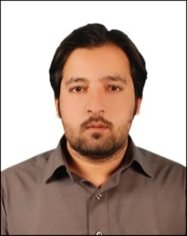
Whatsapp Mobile: +971504753686 Phone +97143970978 E-mail: gulfjobseeker@gmail.com
Muhammad (Optometrist)

Objective:
I am searching for an avenue not only to grow more but also to render more in proportionate to my potentials. I want a challenging opportunity for the refinement of my knowledge and to improve the level of my experience as well. I am an ambitious, promising and determined individual with good communication skills and have an aim to become a fellow in optometry. I do not succumb to pressure and eager to learn and develop myself in demanding roles.

Personal Information:
Date of Birth: 30- March-1989
Place of Birth: Swat
Nationality: Pakistani
Marital Status: Single

Education:
2009 – 2012 B.S. Vision Sciences
Pakistan Institute of Community Ophthalmology (PICO), Khyber medical University (KMU), Peshawar, Pakistan.
MAJOR FIELDS: Basic Sciences, Anatomy, Physiology, Pathology and pharmacology of EYE, Refraction, Contact Lenses, Orthoptics, Low Vision.

2007 F. Sc (pre medical) Major Subjects: Chemistry, Zoology, Botany and Physics.

2005 SSC Science Group Major Subjects: Biology, Chemistry, Physics, Math.

WORK EXPERIENCE:
- I served as Optometrist in Pediatric Eye Unit, Department of ophthalmology, Saidu Teaching Hospital, Saidu Sharif Swat, Government of Pakistan since 01-03-2013 to 28-02-2015, (2 Years) employ of the Fred Hollows Foundation Pakistan.
- Presently I am working as optometrist in an optical shop in Dubai since 11th June 2015 till date.

MEMBERSHIP: Member of Pakistan Optometric Society.

LICENSE: Dubai Health Authority
License #
Exp Date:

LANGUAGES: Fluent in English, Urdu and Pashto.

