CURRICULUM VITAE
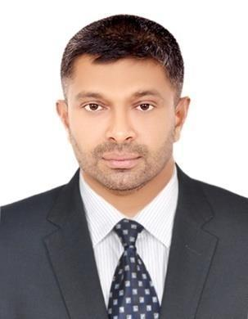

Riyasuddin

E-mail: riyasuddin-284835@gulfjobseeker.com

Career Objective

To secure a position where by hard work, dedication and the ability to acquire new skills will advantage any company I work for.

Education

- Higher Secondary Course, Commerce Group- Kerala, India

- SSLC (Secondary School Leaving Certificate)- Kerala, India

- Diploma in computer applications (Syllabus –Microsoft office-Word, Excel, Power Point, Windows XP, Windows 7, Internet)

Work Experience

Designation: PUBLIC RELATION OFFICER & REAL ESTATE ASSISTANT

[2007 to Current Date]

Experience:

- Handling Public Relations Documents (PRO for Tasheel ,Emigration & Medical)

- Managing Real Estate Section & Tenancy contract (Real Estate Assistant)

- Office administration

- Document Processing

- HR Assistant

- Banking services

- Arabic speaking and typing skill

- Arranging and organizing company social events

- Managing employment visa, passport control, medical insurance & Emirates ID

- Company name: INDIA INFOLINE LTD. - BOMBAY, INDIA

Designation: OFFICE ADMINISTRATOR

[January 2004 to November 2008]

Experiences:
- Assisting Administrative Staff on daily operations

- Managing timely distribution of bills & statements to clients

Personnel Information

• | Gender | : Male
• | Religion | : Islam
• | Marital Status | : Married
• | Nationality | : Indian (Kerala)
• | Birth Date | : 29/05/1974
• | VISA status | : Employment
• | VISA Expiry | : 12/03/2021
➢ | DRIVING LICENCE | : Valid UAE and INDIAN license
➢ | LANGUAGES KNOWN | : English, Arabic, Hindi, Malayalam

Declaration

I hereby declare that all information and details given above are correct and true to the best of my knowledge.

