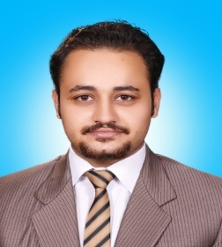
PERSONAL DETAILS

Name :Shehreyar
Place and Date of Birth :Mardan 11th July 1993
Sex :Male
Marital Status :Single
C/o-Mobile Number +971501685421
Email : shehreyar.288126@2freemail.com

EDUCATION

- October 2015 BS Software Engineering at City University Peshawar
Major : Database Sql,Mysql,Networking,SPM,Android
CGPA 2.78
- 2009-2010 Finished Intermediate at ICMS college peshawar
Total Marks Obtained Marks
1100 765
- 2007-2009 Finished Matric at Iqra School System
Total Marks Obtained Marks
1050 755
- 14/9/2015-20/9/2015 CCNA/CCNP 6 Days Workshop at Grow wide Peshawar

OTHER SKILLS
- Microsoft Excel
- Microsoft Word
- Microsoft Power Point

SOFTWARE ENGINEERING SKILLS
- Database Sql,Mysql
- Networking (Cisco Packet Tracer)
- Software Project Managment
- Android

EXPERIANCE
- Worked as a “social mobilizer, monitoring supervisor & Data Entry operator on volunteer bases” From 1st nov 2015 to 31st oct 2016 in literacy sector data collection in Mayar district Mardan At National Commision For Human Development (NCHD).
- Served as a “Computer Operator” From 15th November 2016 to 15th May 2017 At Souvenir tobacco company limited Distt Mardan.

REFERENCES
References are available upon request.

