Ali.288530@2freemail.com 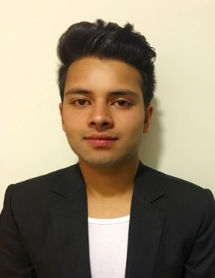
ALI
VISA :VISIT VISA
Brief Overview
A competent professional with over 2 years corporate experience in , Customer Support and service Management.
Objective
To obtain a challenging position, utilizing proven abilities developed through my experience and education with opportunity for professional growth and merit performances.
Work experience
Position – Customer Service Representative
Location – siliguri, India.
Period – Sept 2015 to MARCH 2016

- Welcome customer with a smile and greeting.
- Sale of motor bikes/ Cashier
- Billing and costing price to the customer.
- Giving the customer best service .
- Reporting daily sale report to the store manager .
- Take ownership of queries and proactively follow through to resolution.
- Creating a combination of real value for money and outstanding customer service.

Company – American Express
Position – Call center executive
Location – Bangalore,India
Period – Jan 2014 to July 2015

Duties And Responsibilities
- Responsible for handling inbound & outbound calls for 2 American Express platforms - CCSG (Consumer Card Service Group) & Returned Checks (NG) division. I joined as a CRA
- Dialed Outbound collections for Capital One I worked in a highly competitive and result oriented environment involving inbound/outbound calls to U.S. based client
- The job encompassed skillful negotiations and high dollar balances in meeting daily parameters of cash collected and month end actual cash retrieved
- As a credit collector for Amex credit cards I worked in a highly competitive and result oriented environment involving inbound/outbound calls to U.S. based clientele
- The job encompassed skillful negotiations and high dollar balances in meeting daily parameters of cash collected and month end actual cash retrieved
- As a collector I made prompt and conclusive decisions on important financial aspects like card suspensions and penal action
- Recipient of awards for consistent performance and extraordinary customer service

EDUCATION

- Passed ICSE from Vidya Vikash Academy
- Passed ISC from Vidya Vikash Academy.
- Mass communication from St. josephs college,Darjeeling.
Personal details
- Language English,Hindi,Nepali,Bengali
- Marital status Single
I hereby state that the above stated details are true to my knowledge.

