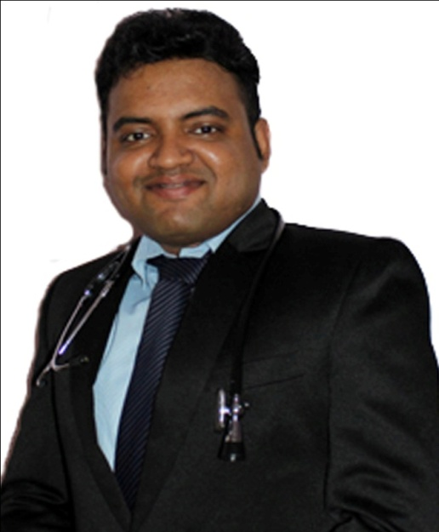

Dr. Sourav
SOURAV.292509@2freemail.com

- General Practitioner
- Al Barsha Clinic
- Dubai, UAE
________________________________________________________________________

Career profile:

Highly motivated, dedicated and clinically competent general practitioner with 4 years of experience caring for patients from a range of cultural backgrounds. A patient advocate known for working closely with hospital staffs and high stress environments. Able to cut patients at ease and establish subtle and often difficult to make diagnoses. I am committed to pursue a role in which I can help people maintain their health and quality of life.

Current employment

Al Barsha Clinic (September 2016- Present)
Al Quoz Industrial Area 1
Dubai, UAE
____________________________________________________
Number of patients seen:
40-50/day

Special interests:
Diabetes, Hypertension, COPD, Heart Diseases and other chronic diseases

Skills:
Suturing, Dressing, Minor operations like Abscess drainage, Toe nail removal etc.

Responsibilities:

- Prescribe or administer treatment, therapy, medication, vaccination and other specialized medical care to treat or prevent illness, disease or injury.
- Order, perform, and interpret tests and analyze records, reports and examination information to diagnose patient’s condition.
- Collect record and maintain patient information such as medical history, reports, and examination results.
- Explain procedures and discuss test results or prescribed treatments with patients.
- Advise patients and community members concerning diet, activity, hygiene and disease prevention.
- Coordinate with nurses, social workers, rehabilitation therapists, pharmacists, psychologists, and other health care providers.
- Operate on patients to remove, repair or improve functioning of diseased or injured body parts or system
- Plan, implement or administer health programs or standards in hospitals, businesses or communities for prevention or treatment of injury or illness.

Personal details:

Name: | Dr. Sourav
Age: | 29 Yrs.
Gender: | Male
Educational Qualification: | MBBS, ACLS, BLS
Professional Experience: | 5 Yrs.
Current Location: | Discovery Gardens, Dubai, UAE
Visa Status: | Residence Visa
Visa Expiry Date: | 24.06.2018
Company type: | Medical, Healthcare
Post Applied for: | General Physician
Notice Period: | 1 month

Skills:

- 5 years of experience and in depth knowledge as a general practitioner.
- I have a welcome and warm personality and welcome every patient with a smile which let me gain their trust.
- Knowledge of and ability to apply professional medical principles, procedures and techniques.
- Thorough knowledge of pharmacological agents used in patient treatment.
- Effective verbal and written communication skills along with proper telephone etiquette.
- I perform in a tactful and professional manner.
- Significant expertise in interpreting ECG, X-RAY, CT-SCAN, and other laboratory and radiological investigations to correlate clinically.

Medical Registration

Medical Council of India: (WBMC)
Dubai Health Authority: DHA-P-

Education

Calcutta National Medical College (2006-2012)
Kolkata, India
_____________________________________________________________

Degree: MBBS
Board certified: West Bengal University of Health Sciences

Previous employment

Belle Vue Clinic (August 2013-August 2016)
Kolkata, India

_____________________________________________________________

Position: General Physician, Emergency Medical Officer

Responsibilities:

- Prescribe or administer treatment, therapy, medication, vaccination and other specialized medical care to treat or prevent illness, disease or injury.
- Order, perform, and interpret tests and analyze records, reports and examination information to diagnose patient’s condition.
- Collect record and maintain patient information such as medical history, reports, and examination results.
- Explain procedures and discuss test results or prescribed treatments with patients.
- Advise patients and community members concerning diet, activity, hygiene and disease prevention.
- Coordinate with nurses, social workers, rehabilitation therapists, pharmacists, psychologists, and other health care providers.
- Operate on patients to remove, repair or improve functioning of diseased or injured body parts or system
- Plan, implement or administer health programs or standards in hospitals, businesses or communities for prevention or treatment of injury or illness.
- Perform emergency procedures like Endotracheal Intubation, Transvenous catheterisation, Temporary pacemaker insertion, Chest tube insertion etc. as and when required.

Calcutta Medical Research Institute (July 2013-Oct 2015)
Kolkata, India
_____________________________________________________________

Position: Registrar in ICU

Responsibilities:

- History taking, clinical examination, providing initial management and
- emergency treatment to patients.
- Provide life saving interventions like Endotracheal intubation , transvenous pacing, chest drain insertions, ACLS independently as and when needed.
- Rounds with consultants and ensure proper follow up of their orders.
- I was in charge of wards at nights and was at times offered the position of additional consultant in cases where I had displayed good clinical skills.
- Educate patients on wellness, prevention, and early detection by providing materials and resources to the patients and families.
- Exercise final medical judgment in all issues of health care.
- Document all services in patient medical records.
- Oversee mid-level medical staff as assigned as well as nursing and clinical stuff.
- Assist in the resolution of complaints, requests and enquiries from patients
- Maintain confidentiality of all patient information.

Calcutta National Medical College (July 2012- July2013)
West Bengal, India
____________________________________________________

Position: House physician

Responsibilities:

- I used to work at Calcutta National Medical College and Hospital. It has 600
- Hospital beds and has the busiest emergency room in ASIA
- I spent 3 months as an intern and one year as a house staff there while working for the Anesthesia department.
- I had learned life saving procedures like ENDOTRACHEAL INTUBATION, TRANSVENOUS PACING and CENTRAL VENOUS CATHETERISATION in that time period.
- I used to perform history taking, clinical examination, interpret investigation reports and decide a proper anesthesia plan with consultants.
- I also used to give rounds with consultants in the recovery room and carry out proper follow up of their orders.

Certificates:

- Advanced cardiac life support (American Heart Association) (April2015-April-2017)
- Basic Life Support (American Heart Association) (April 2015-April 2017)

Preferred work

I would like to work as a General Physician in Dubai, Abu Dhabi, Sharjah, UAE and I can start work within 1 month notice.

Teaching responsibilities

Teaching Nursing staffs and non medical staffs at Belle Vue Clinic on how to provide
Emergency medical care and basic life support.

Personal interests

- Reading
- Writing
- Cooking
- Travelling
- Photography

