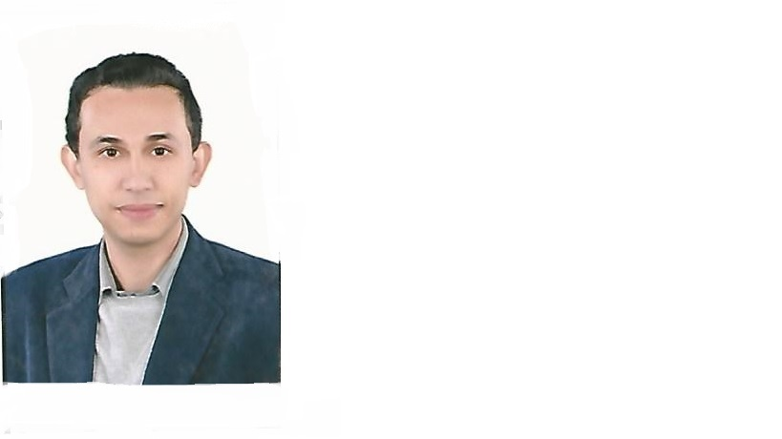 Elsayed
Residence visa, Sharjah
UAE driving license
Tel. C/o 0501685421
Elsayed.293651@2freemail.com

Professional Summary
Experienced dentistwith multiple years of practicing.Highly motivated, dedicated and committed to providing the best possible care with the best possible service. Experienced in all varieties of procedures desired in a professionaldentistry. Friendly and detail-orientated, proficient at developing and maintaining client relationships .
Objective
Ambitious qualified person with excellent organizational and interpersonal skills, want to secure aposition with adynamic and progressive company, ideal candidate for position requiring initiative, responsibility and challenge. Establishing and developing cooperation with doctors and practice staff, Responding and solving customer's problem.Implementing cold call strategies to obtain new accounts.Effective and strong professional communicator.

Education
2009 BDS, Mansoura University, Egypt
CoreQualifications
Good experience in veneers and bleaching
Good experience in handling laser device (Elexxionpico)
Years of experience - Friendly personality - Excellent communication skills - Attention to details - Positive attitude.
Experience
Sep 2009- Feb 2017 : Dentist at MOH, Egypt, providing following:
*Examination , diagnosis and administrative operations
*Dental treatments (prophylaxis, surgical,conservative,endodontic,prosthetic,cosmetic)
Jan2013 till Feb 2017:working at private dental clinic providing following:
*Examination and diagnosis
*Dental treatments (prophylaxis, surgical,conservative,endodontic,prosthetic, cosmetic)

March 2017 till present: working as Dentist in AEMC in Sharjah providing following:
*Veneers , bleaching and laser treatments
*Examination and diagnosis
*Dental treatments (prophylaxis, surgical,conservative,endodontic,prosthetic, cosmetic)

Skills
Languageskills:native language Arabic, good command of both written and spoken English
Computer skills: good knowledge with Microsoft office and internet access

MOH license holder
DHA eligibility letter holder

