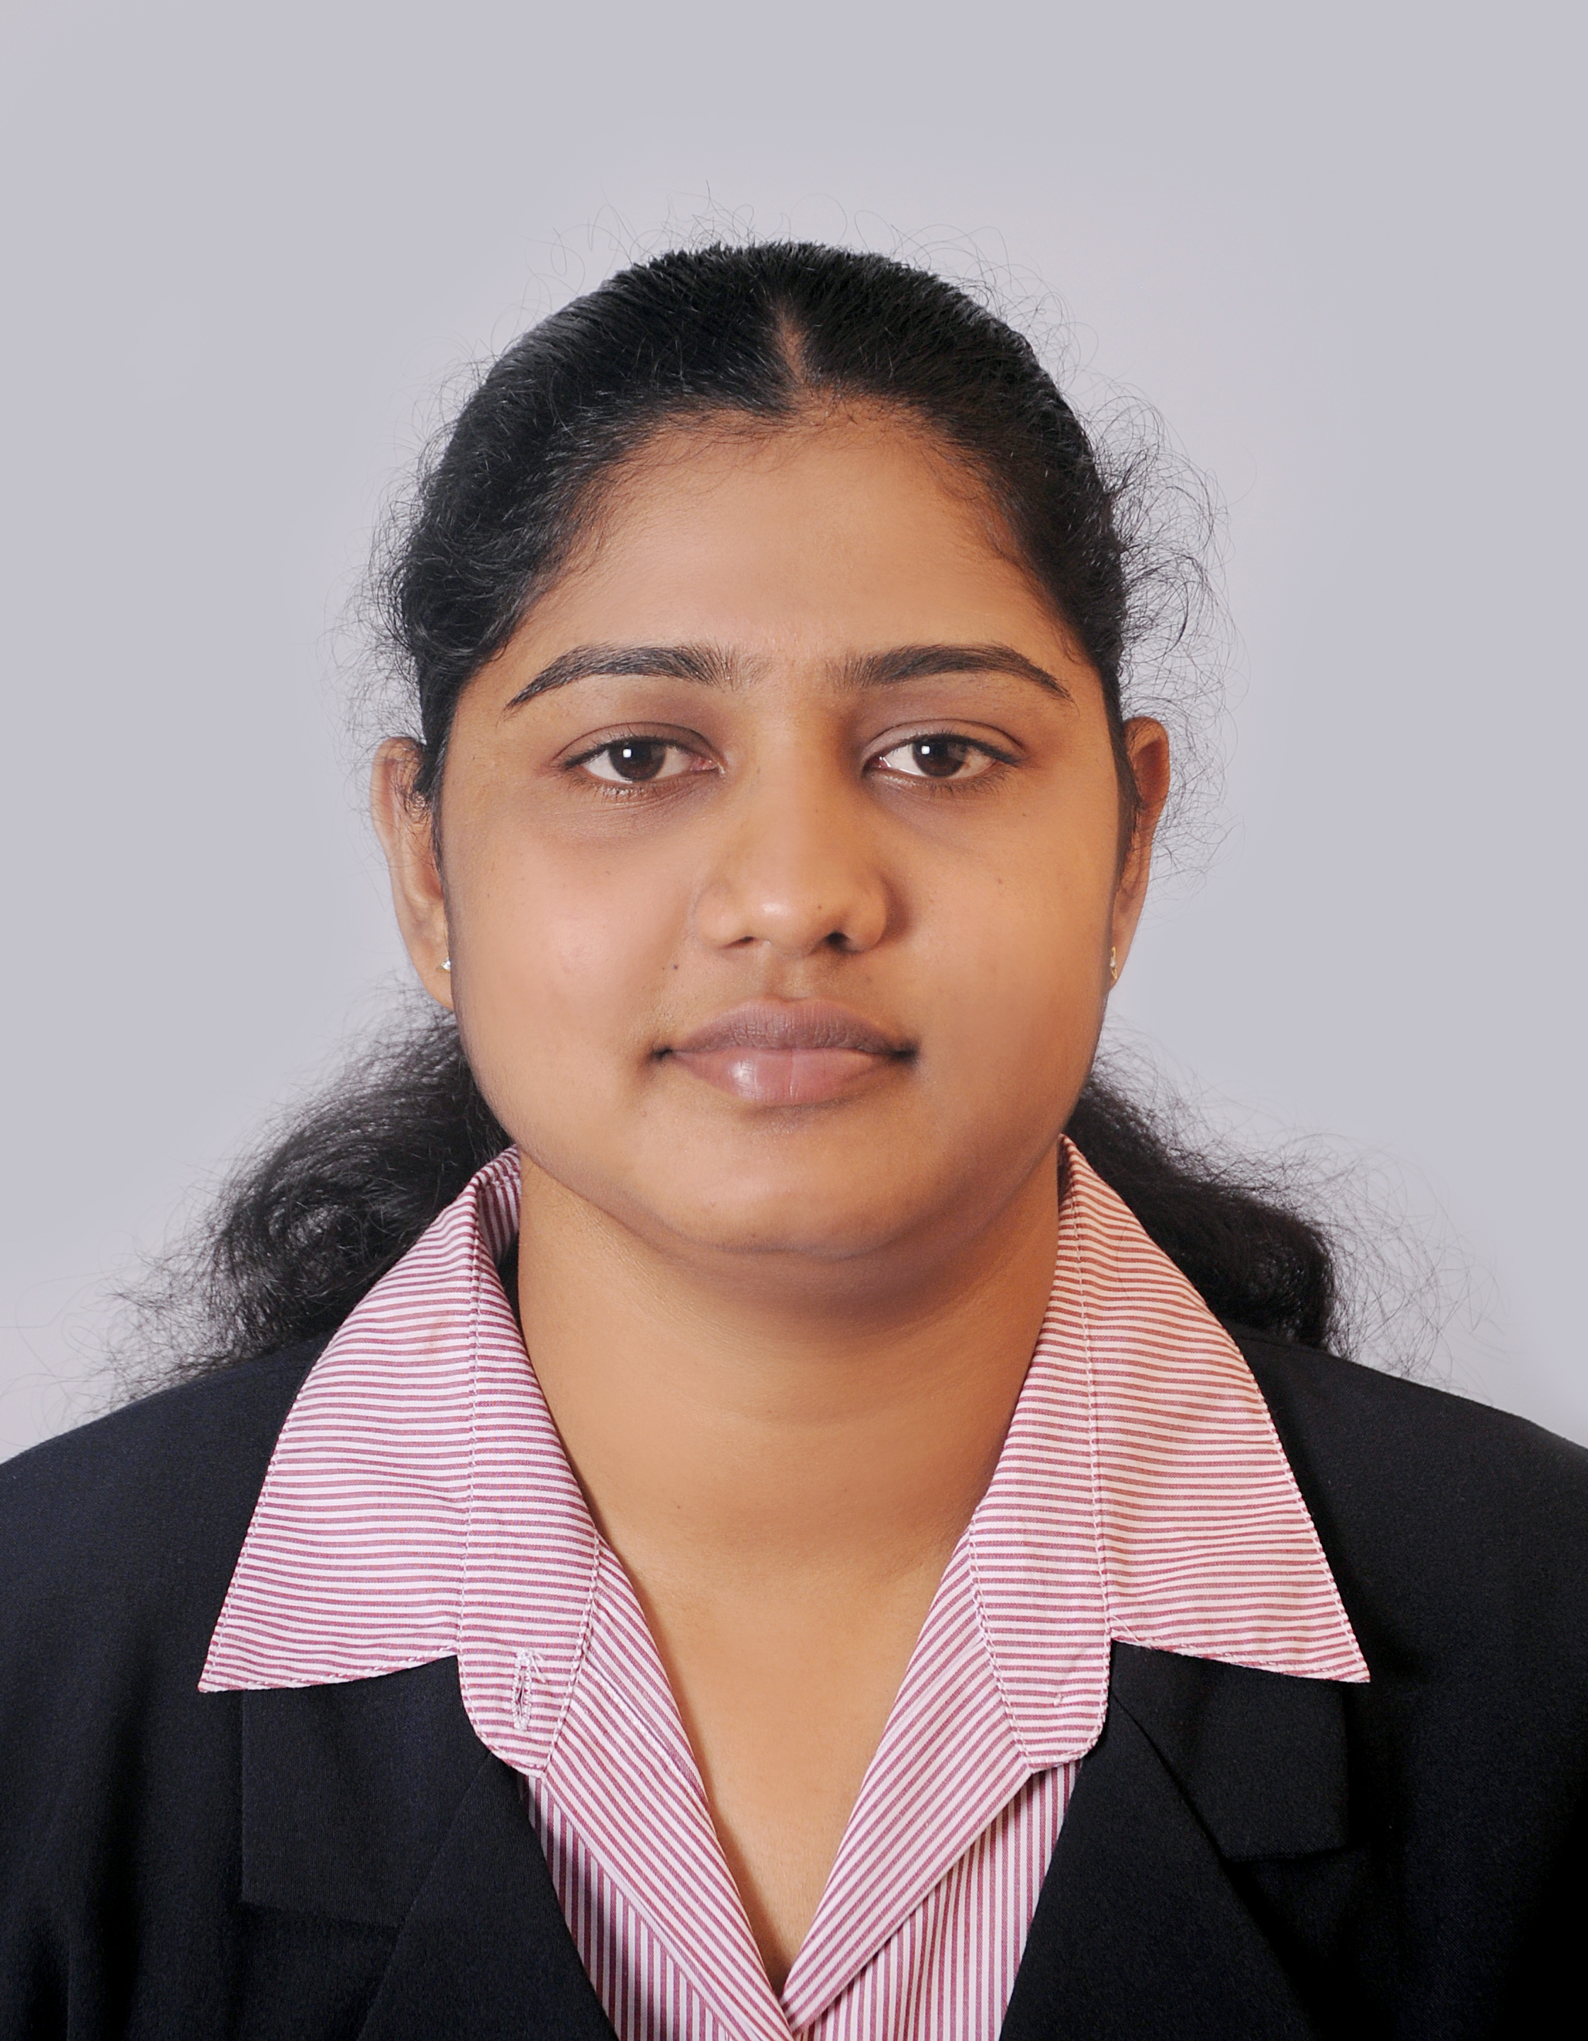

MEKALA

OBJECTIVE : I am seeking a challenging position that will provide me the opportunity to, utilize my skills, knowledge and competencies in order to achieve the company's goals and objectives.

PROFILE : I have been in shipping and Freight for almost 8 years and I have gained an excellent knowledge and experience in all functions of Shipping and Freight.

PERSONAL DETAILS

- DATE OF BIRTH : 12/07/1986

- SEX : FEMALE

- VISA STATUS : VISIT

- KNOWING
LANGUAGES : ENGLISH, SINHALA, & TAMIL.

PROFESSIONAL EXPERIENCE

- Worked as a Assistant Accounts cum Secretary in Business Chamber of Commerce. (06/07)
# Preparing all customers records.
# Maintain all files & Ledgers.
# Banks Deposits.

- Worked as Operations Executive in (Pvt) Ltd. (07/08)

# Creating manifest with bill copies.
# Preparing charge list for shipments.
# Preparing all containers delivery orders.
# Co-ordinate with shipping lines.
# Customer handling with delivery of cargo.
# Overall supervising of company transport affairs.
# Assisting for all operational.
# Prepare all debit notes.

- I Elevated as Accounts assistance cum Customer care Executive in Freight Move Lanka (Pvt) Ltd. (08/12)

# Co-ordinate with Dubai & Local customers regarding delivery of cargo.
# Maintaining employees personal files and leave records.
# Handling customers damage cargo complains and co-ordinate with head office.
# Supervising of company transport affairs and providing a transport to customers.
# Answer to official mails and calls.

- Worked as Operations Executive in Embassy Cargo & Freight L.L.C. Dubai. (2014)

- Now I am Working as Dubai - Customer care Agent in Ceylon Shipping Lines, Colombo 09.

PROFESSIONAL QUALIFICATION

- Completed Diploma in Computer Software Engineering. (2002)
# Fundamentals of IT
Application Software, Computer Classification, Computer Physical units.

# Windows XP

# Word processing Using Microsoft Word XP
Ms - Word ‘97/2000'

# Microsoft Excel XP
Work sheet, File summary, Book Arrangement.

# Microsoft Power Point

# Database Management using Microsoft Access XP
Creating a Database, Fields, Data Types, Adding Records, Page setup.

# Visual Basic Programming Enterprise Version 6.0
Work with Forms, Controlling Program Execution, Define Menus, Data Form Wizard.

# Microsoft Disk Operating System 6.22

# Internet & E-mail

- Completed Diploma in Computerized Accounting. (2004)
# MS DOS
# Windows 97
# Windows 2000
# Simple Accounting
# General Ledger
# Vendors Ledger
# Inventory Ledger
# Project Work

- Completed Diploma in Quick Book. (2004)
# Create new company & Institution Details.
# Creating the General Ledger.
# How to using the Payment.
# How to set up and link account.
# Purchases Transaction.

- Completed certificate course in Operational Aspects of International Trade - 2015 in Sri Lanka Export Development Board.
- Completed Diploma in Business Management Cum Human Resource Management in
London Tec. (2015)

- Completed Spoken English & Grammar course in American College of Higher Education. (2007)
- Completed Yoga Instructors Course in Bangalore, India. (2008)
- Completed English Language course in University of Colombo. (Intermediate Level) (2009)
- Completed English Language course in University of Colombo. (Higher Level) (2010)

EADUCATIONAL QUALIFICATIONS

G.C.E. O/L EXAMINATION 2002.

SUBJECTS GRADE

Commerce B
Tamil B
Religion C
Music C
Health Science C
Mathematics S
English S
Science S
Social Studies S

G.C.E. A/L EXAMINATION 2005.

I have sat for the Examination

SCHOOL ACTIVITIES

- Took part in Debate Competition in Tamil Literary Union.
- I am Board of Director Leo Club of St. Anne's 306B.
- Participated in Sports Inter School Level with Certificate of Merit Level.
- Sport Activities in School Level.
- Took part in Speech Music competitions in 1995.

I hereby certify that the above particulars furnished by me are true and accurate to the best of my knowledge.

Mekala
CV NO: 1765398
Click to send CV No & get contact details of candidate


