CV
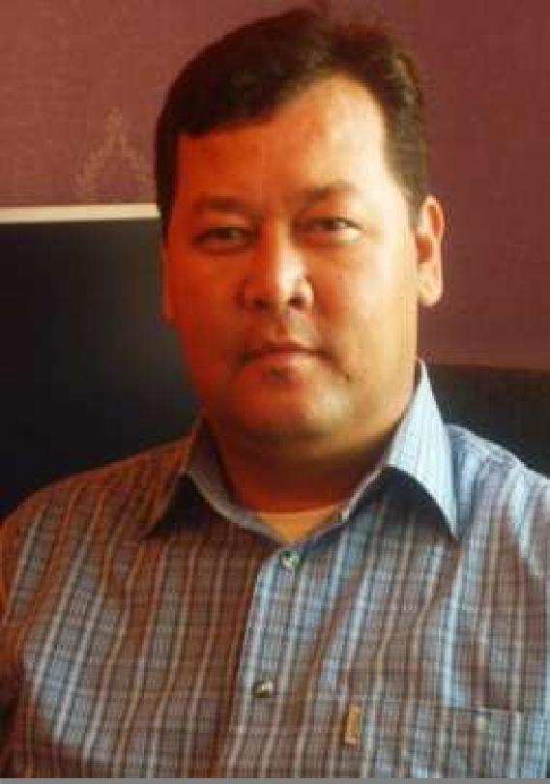

Personal Data
First & Last name | Charymurat
Nationality/ | Turkmen |  |  | Male
Gender
Country & City of | Turkmenistan |  |  | Ashgabat
residence
Date & Place of | 02.04.1976 |  |  | Turkmenistan
birth
Age/Height/Weight | 40 | 185 |  |  | 100
Status/ Children | Married |  |  | 4
Phone (Home/Cell)
E-mail | Charymurat.297474@2freemail.com
Driving license | No
Health (chronicle | No
diseases, serious
problems)
Criminal Status | No
(convicted)

Summery:

As Civil Architect & Designer with many years of experience in concept drawings and design in various building projects I am offering strong knowledge of the different stages of Architectural design development along with expertise in employing methods to bring construction projects to completion in a time efficient manner. A meticulous approach coupled with a professional attitude and excellent communication skills will ensure the effective running of various tasks involved in the running of a project. Being a highly committed and hard working person, I have been developing my social, technical and computer skills through my jobs and various courses and have worked within professional teams for the last seven years. An author of various conceptual designs of multi-story housing, banks, mosques, kindergartens, schools, hippodrome, cottages, hotels, reconstruction of the international airport and railway station, hospitals, interior designs.

I am extremely interested in obtaining a job opportunity in Architectural Engineering reputable organization where I could best utilize my experience and skills and contribute to organization success.

Education |  | Specialization |  |  | Month & Year of |  |  |  | City/ Country
Institution name, |  |  |  |  | registration &
(other courses) |  |  |  |  | graduation
The Academy of Art |  | Department of |  |  | Sep 1995 |  | July2001 |  | Ashgabat city,
of Turkmenistan |  | Architecture & Design, |  |  |  |  |  |  | Turkmenistan
 |  | Architect
Turkmen Art School |  | Department of Fine Arts, |  |  | Sep 1991 |  | July1995 |  | Ashgabat city,
named after Shota |  | teacher of drawing |  |  |  |  |  |  | Turkmenistan
Rustaveli
Work Experience
Position |  | Freelance
 |  | Architect/designer
Period (M/Y) / |  | Nov 2011 - Present |  | Ashghabat |  |  |  | Turkmenistan
City&Country
Responsibilities |  | Full space design, whether its interior or exterior.
 |  | Full conceptual and professional drawings that meets the client
 |  | requirements.
 |  | Architectural an Interior Design Services.
 |  | Design of residential and commercial units.
 |  | Conduct varies state and private projects in varies directions.
 |  | Participation in conceptual designs for tenders.
 |  | Residential and commertial architecture, architectural consultations,
 |  | architectural studies and projects for Building Authorities, construction
 |  | details, communication with companies connected with realisation,
 |  | coordination of realisations, authors supervision. Master planning for
 |  | various projects , Industrial projects.
Position |  | “Wahat Al Sarab” Technical works (L.L.C) in Dubai, UAE
 |  | Partner
Period (M/Y) / |  | Aug 2010 - Oct 2011 |  | Dubai |  |  |  | UAE
City&Country
Responsibilities |  | Carried out mural and artistic painting projects for mosques, villas in
 |  | Emirate Hills, Al-Warqaa, Jumeirah, etc.
 |  | Acted as consulter for construction projects.
 |  | Was responsible for budgeting, planning and resource
 |  | management skills to enable a specified end deliverable to be
 |  | completed within the allocated timeframe.
Position |  | Freelance
 |  | Architect/designer
Period |  | 2007 – 2009
Responsibilities |  | Manager of team of 4 architects and engineer, administrator of
 |  | the own art studio, responsible for the day-to-day running of the
 |  | office
 |  | Design and develop the architectural projects to client
 |  | requirements, accountable for budgetary control and for ensuring
 |  | compliance with building and planning regulations.
 |  | Liaising with customers, including government authorities, foreign
 |  | companies and private individuals from initial requirement
 |  | specification through functional specification.
 |  | Cooperating with Joint American-Russian construction company.

Position | Architect/designer
Company’s name | “Asist” Turkish construction company
Period (M/Y) / | Mar 2006 - Apr 2007 | Turkmenistan | Ashghabat City
City&Country
Responsibilities | Gathered and collected design requirements for new
 | constructions, alterations or repairs.
 | Prepared architecture design based on design requirements.
 | Designed and developed conceptual drawings intended for
 | tendering for the building projects of Turkmenistan’s government
 | institutions
 | Provided construction, time, cost, machineries, and other
 | specifications to management.
 | Managed, supported and guided designers involved in preparing
 | drawings.

Position | Civil architect
Company’s name | “Bahar Insaat” Turkish construction company
Period (M/Y) / | Jul 2003 - Dec 2006 | Turkmenistan | Ashghabat City
City&Country
Responsibilities | Worked on new-build multi-story housing projects
 | Involved in the management of a building projects from the initial
 | design stages through to completion.
 | Travelled the sites and attended meetings with clients,
 | contractors and representatives from planning departments

Position | Civil Architect
Company’s name | “Polimex” Turkish construction company
Period (M/Y) / | Jul 2001 - Dec 2003 | Turkmenistan | Ashghabat City
City&Country
Responsibilities | Confered with clients, architects, engineers, etc., to understand
 | their requirements and to get details about the scope of the
 | project.
 | Carried out investigation of the existing social, geological and
 | ecological conditions and the related processes in the landscape
 | and creates designs that would meet with the clients'
 | expectations.
 | Developed plans that would meet with the clients' specifications
 | and are involved in preparing the budgets for the project.

Position | Civil Architect
Company’s name | “BVT” Turkish construction company
Period (M/Y) / | Jul 2000 - Dec 2001 |  |  |  |  |  | Turkmenistan |  |  |  |  | Ashghabat City
City&Country
Responsibilities | Prepared the graphic representations or drawings of the
 | developed plans.
 | Was involved in inspecting the site for the project and analyzing
 | the environmental conditions and preparing the reports of the
 | same.
 | Ensured that all the completed work has been inspected to
 | ensure adherence to the rules, regulations, etc., as well as to
 | ensure high quality standards.
Language |  |  | Written |  |  |  |  | Spoken |  |  |  |  | Understanding
 | 2 |  | 3 | 4 |  | 5 | 2 | 3 | 4 | 5 |  | 2 |  | 3 |  | 4 |  | 5
English |  |  |  | + |  |  |  |  | + |  |  |  |  |  |  | +
Russian |  |  |  |  |  | + |  |  |  | + |  |  |  |  |  |  |  | +
Turkish |  |  |  |  |  | + |  |  |  | + |  |  |  |  |  |  |  | +

Core Skills: Communication, negotiation, team player, problem solving and analytical, management skills.

Computer Skills: MS-Office including MS-Word, MS-Excel, MS-PowerPoint, MS-Outlook, Internet browsing, AutoCAD, Archi-CAD, 3D-MAX, Photoshop, Corel Painter.

Personal Abilities:

Can work under pressure; Possess Strong verbal and personal communication skills; Capable of dealing with customers regardless of their mood in order to sell products; Continue to learn and improve every day; Able to adapt oneself to new surroundings; Set up goals and make sure they are accomplished successfully; Have good teamwork skills; Able easily adopt to changing environment; Never being late to work is another good habit of mine; Energetic in doing any kind of activity.

