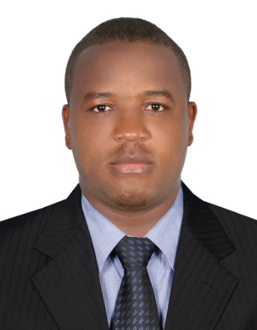
KUM
Email: kum.297770@2freemail.com

Safety Officer

OBJECTIVE:
A meticulous, hard-working and focused professional who has a record of identifying probable risks, preventing accidents and implementing safety regulations. Clovis has considerable experience in a Health and Safety role, and is an expert in the fields of drawing-up safe operational procedures and making recommendations following any accidents or incidents. He is team-oriented, resilient and has a self-consistent personality, along with a very precise and goal-oriented working style. Right now he is looking for a permanent position with a company where there is future potential for promotion based on individual performance.
WORK EXPERIENCE:

Security Guard / Safety Officer Transguard Group LLC Dubai
Dubai International airport (October 2016 to present )
- Secure people, property and information.
- Access control
- Conflict resolution.

Safety Officer Dutch Foundation Concrete Processing Co L.L.C Dubai
Zabeel site Dubai (September 2015 – May 2016)
- Ensuring compliance with current legislation.
- Making regular sites inspections.
- Maintaining proper record.
- Conduct training courses.
- Advising managers, colleagues of safe working practices.

Camp Boss Dutch Foundation Concrete Processing Co L.L.C Dubai
Jabel Ali Accommodation (November , 2014 – August , 2015)
- Maintaining documents related store, laundry camp management and civil defense documents.
- Dealing with occupants queries and complaints
- Ensure timely ordering and maintenance of inventory of all camps supplies, tools and equipment necessary for maintenance and operations of the camps facilities.
- Act as payroll for new employees.

Economics and Commerce Teacher Government Bilingual High
School Bonaberi
Douala City, Littoral, Cameroon (July, 2012 – September ,2014)
- Assessing, recording and reporting on the work of students.
- Preparing students for examinations.
- Developing and implementing creative educational learning plans.
- Highlighting any concerns about a students performance and progress.
- Setting and enforcing deadlines for students work.
- Accomplish regular lectures and practical works.
ACADEMIC BACKGROUND:
COLLEGE: Bachelor of Social Science in Banking and Finance
Buea University – Cameroon
Buea city, SWR (2010 – 2014)

ACHIEVEMENTS:
- Awarded IGC3 Certificate in Occupational health and safety from NEBOSH London (UK)

SEMINARS/CONVENTIONS ATTENDED:
FFG Business: Prof. Mbuh E. Douala - Cameroon October 23, 2012

Marketing : Marketing Principles
Mr Neba Emmanuel (Director of institution) PAID-WA -Cameroon Oct. 9, 2013
Uncovering the Financial Statements: Techniques in Interpreting Financial Statements
Mr. Aseh (Phd student) - BUST University of Bamenda, Cameroon Nov. 15, 2013

SKILLS
- Good Communication background (Fluent in English Language and partial French).
- Can work under pressure, self-motivated and flexible.
- Ability to work as a team and independently.
- Creative, analytical, passionate, integrity, discipline and professional.
- Good computer knowledge and willingness to learn new sales tools.
- Able to teach across all stages.

RELATED COURSE WORK:
- Financial Accounting / Managerial Accounting / Business Law / Customer Service
- Organizational behavior / International Business Communication (IBC).
- Economics for Business / Marketing Principles / Business Statistics & Numeracy

PERSONAL DATA:
Age : 29
Gender : Male
Date of Birth : June 04, 1987
Place of Birth : Wum, Cameroon
Marital Status : Single
Nationality : Cameroonian
Visa Status : Employment under Cancellation

I hereby certify that the above information is true and correct.
(Kum )

