SUSSETTE
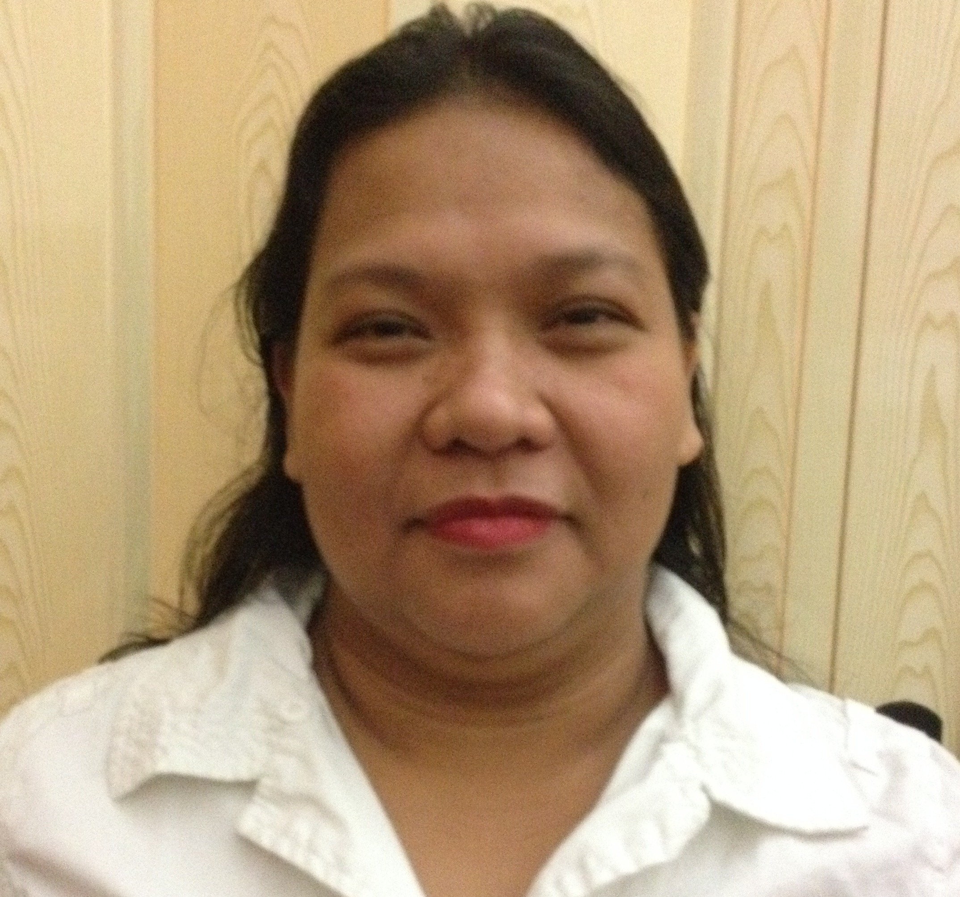

Profile :
Financed education with experienced as a Teacher
Special talent for motivating children in all backgrounds.
Work well under pressure situations maintaining a professional and concerned manner.
Service oriented and Goal-directed, equipped with knowledge, understanding, skills and desirable attitudes coupled with responsibility, gentleness and respect in order to provide a dedicated pupils and students, necessary to develop and maintain Emphatic relationship with children.
Enthusiastic, creative and versatile.

Work Experience :

Child Development Supervisor
Martha’s Daycare and Afterschool Care
7240 180st. NW, Edmonton,AB
November 2011 – May 2016

Competencies and Experiences :
Supervises the creation of an invitational program for the children to include activities
that support all areas of development such as music and singing, story reading, art
activities, games that support social growth and physical movement activities.
Activities should be child appropriate and respect and support the values and traditions
and language of participating children.
Establish a positive, warm environment in which the children feel free to express
themselves and choose activities appropriate to their age and personal preferences.
Engage the children in the English language to support them in learning English as well
as supporting parents with the use of their mother tongue.
Ensure safety in all practices at the Child-minding Centre.

Cashier
Dairy Queen
8882 170 St. NW, Edmonton,AB, Canada
November 2012-March 2015

Competencies and Experiences :
Completing money transactions and preparing ice cream.
Answering questions about menu items ,services and policies.
Process customer transactions and maintain an accurate cash drawer throughout shift.
Initiate and complete customer transactions quickly and accurately.
Assemble and deliver order to customers quickly and efficiently.
Complete assigned prep work for stocking and set up of work area.
Assist with end of day cleaning.

Teacher
St. Joseph’s School of Mactan
Mactan, Lapu-Lapu City
June 2002- March 2011

Competencies and Experiences :
Teaching good Values Education.
Meeting with parents, guardians, or other school staff to discuss observations
on children with particular issues.
Instructing children in groups and individually through different approaches.
Assist young children in adapting classroom environment.
Introduce the children to reading, writing and arithmetic.
Help the children to become self-aware, socially aware and more.
Assigning, correcting and grading homework, and preparing report cards.
Establishing and administering grade tests, and recording the results.

Educational Background :

Elementary Iligan City North Central School
Iligan City, Philippines
March 1981 – March 1987

High School Iligan City National High School
Iligan City, Philippines
March 1987 – March 1991

College St. Michael’s College
Iligan City, Philippines
Course: Bachelor of Science in Commerce
Major in Banking and Finance
June 1991 – March 1996

St. Michael’s College
Iligan City, Philippines
Course: Bachelor in Elementary Education
Major in English
November1999 – March 2002

Professional Registration Registered Teacher
Republic of the Philippines
Professional Regulation Commission
Licensed No.

Teaching Qualification Member of National Organization of
Professional Teacher, Inc.

Post Graduate Training :

First Aid and CPR Breath for Life
First Aid Education
4443 99st. Edmonton, AB T6E 5B6

St. Joseph’s School- Mactan
Mactan, Lapu-Lapu City, Philippines
September 12,19 and Oct. 3,2009

The Existence of Special Child As Cebu State College of Science and Tech.
Man, As Human Being and Main Campus, R. Palma St.
Its Fulfillment of Life Cebu City, Philippines
February 17, 2008

Behavioral Problems in School: Cebu State College of Science and Tech.
The Role of Development Delays, Main Campus, R. Palma St.
Special Needs, Temperament and Cebu City, Philippines
Parenting Style February 10, 2008

The Reading Process and Strategies: January 28, 2008
University of San Carlos South Campus
P. del Rosario Extension, Cebu City

Teacher’s Congress: February 2007
University of San Carlos-South Campus
P. del Rosario Extension, Cebu City

New Trends in Teaching Mathematics: February 2007
University of San Carlos-South Campus
P. del Rosario Extension, Cebu City

Communication Skills: October 7-9, 2007 & April 4-8, 2007
St. Joseph’s School- Mactan
Mactan, Lapu-Lapu City

.

SUSSETTE

CV NO: 1805424
Click to send CV No & get contact details of candidate


