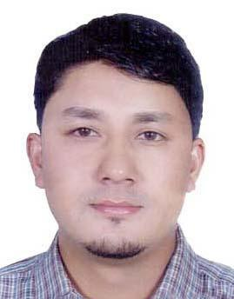
BAHADUR ​

Bahadur.31356@2freemail.com

OBJECTIVE:

Seeks a responsible role with your company as well as the latest technologies and scope for widening the spectrum of my knowledge and skill to develop services for contributing your company’s success by using my experiences and communication skills in any form of service.

EDUCATIONAL QUALIFICATIONS:

- Completed Higher secondary education from Nepal

A.WORK EXPERIENCE DETAILS:

A. Worked as a driver cum merchandiser in Mass Potato Chips Manufacturing and Cheese Dubai (2017 to 2017)

​Ensuring​ that the right amount

of goods are available in store and are being sold at the right price. ...

working closely with buyers and other merchandisers to plan product ranges. meeting with suppliers, distributors and analysts. Managing budgets.

B. Worked as a storekeeper cum Driver in GCC in Iraq (2006 to 2008). Job Responsibilities.
- Store and release supplies or equipments

- Compile the records of the supplies.

- Checking the supplies from time to time

- Record the number and the kinds of supplies.

- Disseminate the supply in its designated areas.

- Securing the status of each supply.

- Checking possible damages or scratches.

B​.​Worked as a Shift in charge in ISTANBUL AL TURKY SWEETS & RESTAURANT Sharjah

.(2011 -2015)

Job Responsibilities.

- To take full responsibility of the shift in terms of management of staff, management of production and quality targets and to ensure the smooth running of the production processes

- To take full responsibility of the quality and product that is produced within the shift in line with the companies quality systems, processes and procedures
- Manage, develop and motivate direct reporting staff​·

- Monitor, measure and report on production related process performance, general issues

- To work closely with other Shift Supervisors to ensure production handovers are effective communications tools
- To ensure that the training skills are met for current and future demands of the shift​·

DRIVING LICENSE DETAILS

- Date of Issue :22/11/2015

- Expiry date : 21/11/2025

- Place of Issue :United Arab Emirates Sharjah

- Job Preference : manual Light Vehicle Driver

- Job Type : Permanent

- Visa Status : Visit Visa

LANGUAGE’S PROFICIENCY:

- English,Hindi,Arabic,​Turkish and nepalis

STRENGTH:

- Self Motive and Capable of Growing with the Institution.

- Capable of Hard Working.

- Good Interaction with Team Members.

- Effective Communication Skills.

- Professional Service and user Satisfaction are My Ultimate Goals.

- Computer literate

PERSONAL INFORMATION:

● | Date of Birth | : | July 14,1985
● | Gender | : | Male
● | Permanent Add. | : | Myagdi, Nepal
● | Marital status | : | Married
● | Nationality | : | Nepali
● | Visa Status | : | visit visa

I, Bahadur assure you that the above mentioned details are true to the best of my knowledge and belief.

