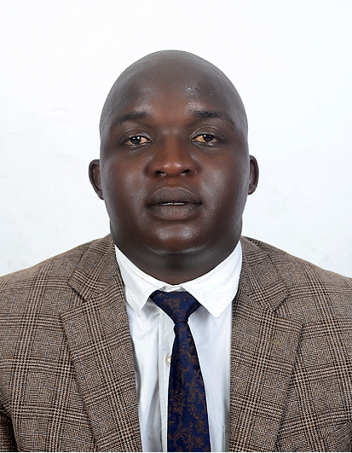
Exceed Confidence Mahiya
Click to send CV No & get contact details of candidate
CV NO: 1835100

biotechnologist

CAREER SUMMARY AND OBJECTIVE

I am a reliable connoisseur of laboratory technician who pays attention to detail, possesses team working and leadership skills is able to work under minimum supervision and accepts correction in carrying out duties and decision making. I am a fast learner who is willing to undertake any training for further knowledge and understanding. Fluent in English, Shona and isiZulu and a competent in MS Office Packages, Electronic Data Processing and Laboratory Diagnostic and Analysis Software. I am seeking a developmental position within a dynamic, goal and success driven biotechnology organization that provides growth and practical challenges to realize my utmost potential

Personal Details
Surname Mahiya
First Names Exceed Confidence
Date of birth 2 March 1989
Sex Male
Age 27
Marital status Single
Nationality Zimbabwean
Visa status Visit/Tourist

Academic Qualifications

COURSE: Bachelor of Technology in Biotechnology
INSTITUTION: Durban University of Technology, Durban, South Africa
Date Graduated: 4 December 2015

COURSE: HGSCE Advanced Level and HGSCE Ordinary Level
INSTITUTION: Saint Francis Xaviers’ Kutama College, Norton, Zimbabwe
Date Graduated: November 2007

Key skills
First Aid Leadership Computer Literacy

Employment History

January 2016 – July 2016: ABI Pretoria (SABMiller), South Africa
Position: Microbiologist

Roles:

- Ensured that collection of samples for testing on water, sugar, syrups, rinse waters, environment, packaging materials, storage and retention samples was done timeously and using aseptic technique. Some sampling points required high physique as they were either at high temperatures, height. Sample collection was very pivotal in the stratification of tests and procedures to be carried out in the microbiology laboratory such that a timeous program I implemented increased functional capacity of the laboratory team. Also carrying out Swab tests on all critical bottling process equipment surfaces to ascertain degree of microbial contamination
- Introduced more environmentally friendly oxonia for the sterilization of product filling environment after having carried out challenge testing experiments. This was also my direct input in facilitating and designing effective microbial control strategies to eliminate microbes on Hazard Analysis Critical Control Points (HACCP). Educated, trained and monitored personnel hygiene practices to ensure biocontrol and elimination of chances of contamination.
- I gave recommendations for improving product microbial and biochemical stability. In this role, I was senior Research and Development scientist where I implemented key research techniques in problem solving. The role required initiative and practical application of scientific skills of mitigating enzyme action through techniques such as blanching, UHT sterilization, pasteurization etc. I implemented a lot of shelf-life solutions through managing to lead a team of subordinates
- Handled consumer quality complaints by identifying problems and led continuous improvement task team in finding solutions to improve customer satisfaction. Personally initiated the carrying out of GMP and Food safety audits on a quarterly basis to ensure adherence to new action plans.
- Maintained and sanitized laboratory equipment and surfaces and was the one to carry out ISO/SANAS 17025 Accredited audit tests under the supervision of auditors. Under my auspices, the laboratory had a remarkable reputation of quality control and standard adherence..
January 2013 – December 2013: Food and Cosmetic Technologies, Durban, South Africa
Position: Microbiologist and Analytical Chemist Intern

Roles:

- Ensured that collection of municipal water, plant (treated) water, sugar, syrups, molasses, lactose, lactulose, rinse waters, environment, packaging materials, storage and retention samples using plating techniques, membrane filtration, microscopy and serial dilutions and subsequent chemical analysis of water, raw materials and final product by UV/VIS spectroscopy, karl-fischer, density, GC, HPLC and colorimetric tests were done timeously and appropriately.
- Testing and approving of line clearance of final product to customers, preparation of standard solutions and conducting training of interns and junior staff.
- Due to my high comprehensive and precise analytical skills I was appointed to Head the Chromatography Department, even as an intern and had to teach even older employees how to operate the GC and HPLC machines. Analysed fat and sugars as well as constitutive probes and forensic probes.
- Calibrated, cleaned and stored all laboratory equipment and apparatus and provided assistance to senior chemists when needed.

