VELMURUGAN  Velmurugan.306245@2freemail.com | 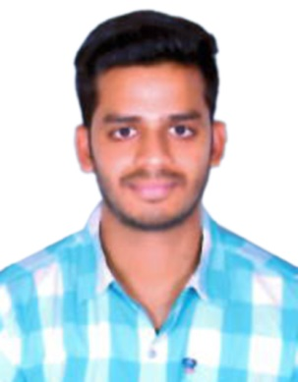
OBJECTIVE:
To utilize my skills and abilities towards prosperity of the organization thereby enhancing my potential ability.

WORK EXPERIENCE
- Worked With MEARSK GLOBAL SERVICE CENTRE as Senior Associate (Logistics) since April 2016.
- Worked with ACCENTURE SERVICES PVT LTD. as Associate (Financial Operations) from February 2015 to March 2016.

JOB PROFILE
- Invoicing customers
- Processing payments
- Processing refunds
- Analysis of Transaction Process
- Gained knowledge on multiple projects under financial operations
- Assigning insurance provider to clients
- Resolving member issues received from on-shore and re-routing issues to appropriate department
- Taking extra initiative to resolve the queries of the team

ACADEMIC QUALIFICATION
- Graduation
Degree : Bachelor in Accounting and Finance
University : Mumbai University
Passing year : April 2014
Percentage obtained : 55.00 %

- Higher Secondary Education
Certification : H.S.C
Major : Commerce
Board : Maharashtra State Board (Mumbai Board)
Passing year : February 2011
Percentage obtained : 66.83 %

- Secondary School Education
Certification : S.S.C
Board : Maharashtra State Board (Mumbai Board)
Passing year : March 2009
Percentage obtained : 55.23%

ADDITIONAL QUALIFICATION
- Tally 9.0
- MS-CIT

PERSONAL DETAILS
Date of Birth : 2nd June 1993
Gender : Male
Marital Status : Single
Nationality : Indian
Languages Known : English, Hindi, Tamil and Marathi
Hobbies : Listening to songs, playing cricket

References
- Will be provided on request.

I do hereby declare that the above information is true to the best of my knowledge.

