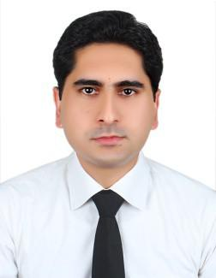
SHAJAH

Email: Shajah.306782@2freemail.com

PERSONAL PROFILE

Seeking position, where a hospitality professional can add value, achieve professional excellence and steady growth. To be part of a team, contributing, learning and enhancing my developments to achieve new heights in the field of Cash Management r (Any suitable position)

KEY SKILLS
- To become a professional and strategic decision maker.
- Able to identify problem and promote solution.
- Interpret instruction and carry out policies accurately.
- Willingness and ability to take on responsibility.

KEY EXPERIENCE
- Over 5 years in the field of Finance and accountancy.
- Communication and interpersonal skills for effective teamwork.
- Knowledge of Internet, Email access and data applications.

- Able to work under own initiative with minimum supervision.

EDUCATIONAL QULIFICATION

- Completed Bachelors degree in commerce.

LANGUAGE
- English
- Urdu

WORK EXPERIENCE

- Work as office Assistant for 1 year in Pakistan.

- Work as Office clerk in Abudullah yousuf al marzouqi for 2 year

- Work with York International Hotel as Club Cashier 6 years.

Responsibilities:

- Managing daily sales report.
- Managing Customers billing Transactions.
- Credit card and Cash Payment Receipts.
- Providing daily operations report to account department.
- Providing orders to relevant department for services.
- Working on IDS Software for accounts management.
- Petty Cash Management for day to day expenses.

PERSONAL DETAILS

Date of birth | :12-08-1984

Nationality : Pakistani

