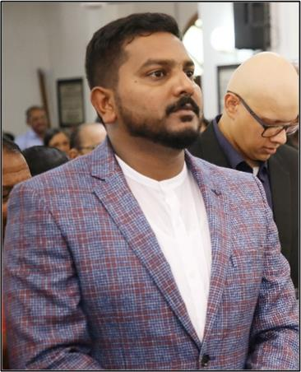

SKILLS
- Operating System: Windows family.
- Application software's : MS Office (Word, Excel, Power Point and Access)
- Risk management processes and analysis
- Self-motivated
- Extremely organized
- CPR and Child CPR Training
- Good Estimator
- Powerful negotiator
- Strong verbal communication
- Client assessment and analysis
- Report analysis

EDUCATION
2008-2012
Anna University | Chennai Bachelor of Engineering: Electrical and Electronics Engineering
with 82.27%.

CERTIFICATIONS
- NEBOSH LEVEL 2 Award in Health and Safety.
- Certified First Aider(Basic plus CPR , AED and First Aid for adults valid till august 2020)

ROYSTON

royston-307301@gulfjobseeker.com Manama, Bahrain

PROFESSIONAL SUMMARY

•Professional experience as Project Coordinator (ALBA PS 5 Expansion Project by GAMA Power Systems), OHS Engineer and Sales Engineer (BMP) at ScopeServ WLL
•Professional experience as Sales and Service Engineer at Integrity services.
•Professional experience as Maintenance Engineer at Dar Akbar Al Khaleej Printing and Publishing.
•Professional experience as Service Engineer at USAM Cad soft India Private Ltd
•Ability to work independently with minimum supervision in a team
environment.
•Excellent command overwritten and verbal communications.

WORK HISTORY
08/2017 - Current
In Bahrain

Position: Project Coordinator (ALBA PS 5 Expansion Project by GAMA Power Systems), OHS Engineer and Sales Engineer (BAPCO Modernization Project)

  - Communicate effectively with the Project Manager, Project Administrator, sales office contacts, Local Business Partners and customers' buyers and documentation controllers.
  - Worked with project owners and team members to set challenging but realistic goals.
  - Maintained project schedules by managing deadlines and adjusting workflow as needed.
  - Documented all hours and budget expenses.
  - Cost Control.
  - Perform site inspection prior to scheduled work on site.
  - Perform risk assessment and advice necessary requirements as per safety standards of employees.
  - Prepare HSE procedure for client approvals.
  - Provide HSE training for employees.
  - Run status reports and lead Document status update meetings.
  - Handling IT issues as well.
  - Handling Inventory of PPE and all other technical tools.
  - Active involvement both HSE Sector and Operations Sector for other shut down projects undertaken by the company.
  - Meeting Clients for BMP Project.

    - Getting RFQ’s for BMP and other projects.
    - Preparing estimation as per client requirement and submitting before deadline.
    - Involving in price negotiation if required.

07/2016 - 07/2017
In Bahrain
Position: Sales and Service Engineer
    - Involved in sales, direct marketing and servicing of Home Appliances Brand named SWAN.
    - Assisting system administrator in IT issues.
    - Inspection of incoming and outgoing materials and conduct material evaluation.

11/2014 - 07/2016
Printing and Publishing company
Position: Maintenance Engineer | Bahrain
    - Involved in trouble shooting and rectifying of both electrical and mechanical problems.
    - Involved in machine assembling.
    - Inspecting transformers, generators, compressor and electrical panels if any fault occurred.
    - Managing inspection of incoming new materials and conduct material evaluation.
    - Keeping updated records of maintenance works.

07/2013 - 07/2014
in India
Position: Service Engineer
    - Involved in servicing of computer hardware and large format printers.
    - Involved in assembling of large format plotters and printers.
    - Involved in installation of operating system and to configure system as required.
    - Inspection of the assigned works among the workers and ensure the work is going as per scheduled.
    - Manage inspection of incoming new materials and conduct material evaluation to determine acceptability based on purchase acceptance standard set by the company.

ADDITIONAL INFORMATION
    - Driving license: Valid Bahrain driving license.
    - Date of Birth: 08-April-1990.
    - Gender: Male.
    - Nationality: Indian.
    - Languages Known: English, Hindi, Tamil & Malayalam.
    - Marital status: Unmarried

.

