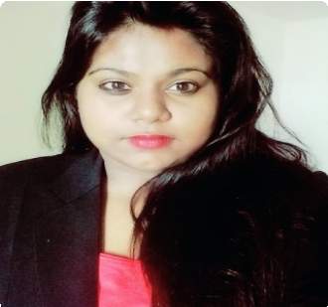
Deborah

Deborah.307591@2freemail.com

Objective
I am looking for a more challenging job in an organization with long term prospects. My technical field concerns mostly in areas on IT business analysis(Business Analyst) and business intelligence, MySQL database management, Cyber security, Testing, Network infrastructure. I am extremely hardworking and willing to work at flexible timings, I am an excellent team player and have leadership qualities.

Work experience

Maple CRM- Denisys Technologies Nov 2016 — Aug 2017

Business Analyst

Training on system configuration based on the requirements of the clients.
Providing a feasible IT solution for various business proposals, Creating API link integration to different websites. Maintained good communication and interactive approach with the clients.
Training in php and MySQL database for backend website application. Understanding the basic knowledge on Angular JS on an ionic framework.

Svar Solutions

Trainee

Experienced as a "On the Job Trainee" (OJB) where i went through a pre process training. Performed general office duties and administrative tasks.
Prepared weekly confidential sales reports for presentation to management. Managed the internal and external mail functions.

Qualifications

Obtained my Bachelors in Information Science at St Josephs Engineering College, Mangalore.
Certification in Cyber Forensics, Cyber Crime and Security and Cyber Law from IFS Education Department. One day training session on Visual Basics held at SJEC during the year 2013.
Oracle Database 10g workshop during the year 2013-2014.
Certification in Web Component Development using Java Technology at NIIT during the year 2013-2014 Certification in developing Web Applications using ASP.NET at NIIT during the year 2013-2014.
Attended a workshop on 'WORKING WITH MICROSOFT VISUAL STUDIO' organized by St Joseph Engineering College.
Certified and completed the course on developing mobile apps for Android application.

Education

Information Science and Engineering Aug 2011 — June 2016

Visvesvaraya Technology and Engineering

Obtained my Bachelors in Information Science at St Josephs Engineering College, Mangalore.
My college group project is based on Real Time Hospital Management System where information can be retrieved from the database by either the doctor and their respective patients where prescriptions and details of the reports are stored on the database. The application was created for doctor patient confidentiality and by using NFC making it highly secure.
Participated with contestants in NETWORK KING COMPETITION in 2013. Participated in preliminary round of Aqua Regia- The Science Quiz in 2014.
Participated in departmental of physical education in throw ball at the inter-class competitions held during the academic year 2014-2015 and also won in Mangalore city level sports in the game of handball.

Cyber Forensics, Cyber Crime, Cyber Law & Cyber Security

IFS
Feb 2013 — Aug 2014

Certification in Cyber Forensics, Cyber Crime, Cyber Law & Cyber Security from IFS. Conducted several case studies and analysis on different threats

Interests
My passion for travelling, I enjoy swimming as well. Reading novels and watching documentaries.

