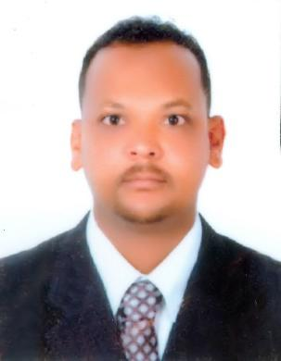

ABDELMONIEM

Al-Qusais, Dubai, U.A.E.

Email: abdelmoniem.307686@2freemail.com
Mobile: Whatsapp +971504753686 / +919979971283

Objective

A highly competent and team spirited Laboratory Technologist, offering nearly 6 years’ experience, recognized for excelling in fast track, high stress environments. Capabilities perform testing within recognized Turnaround time. Accomplished professional, who works closely with hospital staff and administration with full adherence to policies and procedures and excelling regulatory compliance standards.

Gained exposure to heavy work load together with work stress that enhanced capability to focus, react and manage appropriately in a systematic way and to solve quality / automation problems as fast as possible with the priority to accurate result reporting. A team player which works in harmony with medical staff, administration and patients to ensure high quality medical attention consistent with organizational standard procedures. Excellent communication and interpersonal skills which provide a foundation to effectively network collaborate and maintain positive relationships.

Procedural Skills

I have 6 years’ experience in laboratory I work in the following sections:

Hematology. Clinical chemistry. Blood bank .microbiology. General routine. Serology and hormones ..phlebotomist

I can work all investigation by manual hand and Automation.

I worked on the following devices: COBAS c111. COBAS e411-I chroma II-A fais 6

. MINDRAY Chemistry and HORIBA MEDICAL and SYSMEX

D HAPASSED GENERAL LABORATORY TECHNICIAN (Rf DHA/LS/452016/591780)

Work Experience

Company

: Academy Charity Teaching Hospital, Sudan Designation: Lab Technician

Duration

: 2012 – 2017

Company

: EL-TAMEUZ EMERGENCY & TRAUMA CENTRE

Duration

: 24-01-2016 –09-08- 2016

DUTIES & RESPONSIBILITIES

Assist hospital physicians in the diagnosis and treatment of illnesses, injuries and medical conditions by providing clinical testing and specimen analysis.

Conduct lab tests in the areas of hematology, coagulation, urinalysis, serology, immunology, bone marrow and FNA collections.

Prepare chemical solutions, reagents and specimens for microscopic examination; perform laboratory tests; analyze and report findings; and investigate atypical results and discrepancies to determine causation.

Expedite critical testing results without compromising sample validity or quality assurance.

Education

Al Salalb Primary School – Port Sudan

Port Susan secondary School Port Sudan

Diploma in Medical Laboratory technology from University of Juba, Sudan

Personal Details
Nationality | : Sudanese
Date of Birth: 20/10/1981
Marital Status:Single
Religion | : Muslim
Gender | : Male
Languages | : English, Arabic

Passport Details
Date of Issue | : 30/10/2014
Date of Expiry | : 29/10/2019
Place of Issue | : Port Sudan
Visa Status | : Visit Visa

