CURRICULAM VITAE
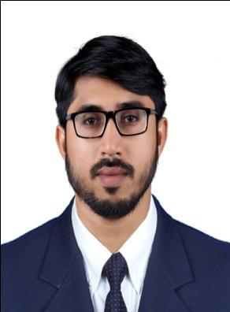

ANEEB M.C

MSc. Nursing
Click to send CV No & get contact details of candidate
CV NO: 1847640

PROFESSIONAL & ACADEMIC QUALIFICATIONS

- Dubai health authority (DHA) RN Exam passed

Ref: DHA/LS/

Issued Date: 08-Aug-2016 Valid up to 08-Aug-2017

- Masters in nursing (Psychiatry): Studied in B.M.S Hospital Nursing College N.R Colony (Bangalore) India affiliated to Rajiv Gandhi University of Health Sciences, Karnataka (2011-2013)

- Bachelor of Nursing: Manjushree College of Nursing College R.T Nagar (Bangalore) India affiliated to Rajiv Gandhi University of Health Sciences, Karnataka (2005-2009)

- Secondary Education : Studied in Markaz Higher Scondary School karanthur Calicut

- Up to 10th Std : Studied in Markaz Higher Scondary School karanthur, Calicut

CAREER OBJECTIVE

To work in your professional environment along with a group of committed people, to contribute my best to the firm, which acknowledges commitment and hard work, thus in turn enhances my knowledge by constant leaning.

PROFESSIONAL EXPERIENCE

Worked in Sri Rama Multi Speciality Hospital Bangalore, Karnataka, India as a

Staff nurse in Medical and Surgical Wards from February 2014 to March 2016.

PERSONAL DATA

♦ Age& Date of Birth | : | 29, 30/05/1987
♦ Sex | : | Male.
♦ Marital Status : | : | Married
♦ Nationality | : | Indian
♦ Religion &caste | : | Islam, Mappila
♦ Passport details
♦ Language Known | : | English, Hindi, Malayalam Kannada, &Tamil.

SKILLED AREAS

- Admission procedure and recording

- ECG

- Cardiopulmonary Resuscitation

- Administration of medicines

- Transfusion and infusion therapy

- Venipuncture

- Intravenous cannulation

- Ryle`s tube insertions

- Chest physiotherapy

KNOWLEDGE OF HANDLING EQUIPMENTS

- Cardiac monitor

- Oxygen apparatus

- Defibrillator

- Ambu bag

- Suction apparatus

- Infusion pumps

- Pulse oxymeter.

- ECG machine

- Arterial and venous catheters

PERSONAL STRENGTHS

- Good Understanding ability.

- Quick learner.

- Hard working.

- Result Oriented.

- Can handle large volume of work with patience and commitment.

ADDITIONAL QUALIFICATION

- Basic Life Support (BLS).

- Microsoft Office.

SPECIAL INTEREST

Play Cricket, Football, Basket Ball, Badminton, Chess, Reading Books and

Travelling.

DECLARATION

I declare that the mentioned facts are true & correct to the Best of my Knowledge & Belief.

Place: Sharjah

Date: ANEEB MC

Visiting VISA Expire on 05/Dec/2016

