**PROFILE**

Well-groomed and talented Business Graduate & Graphic Designer with an ability to contribute a lot in marketing, seeking a challenging and rewarding position in a firm. Strong time management and personal efficiency is well founded in me.

Hard working and motivated toward professional growth.

Functional Area Marketing

o Sales

**CONTACT**



**MUHAMMAD**

[Muhammad.309307@2freemail.com](mailto:Muhammad.309307@2freemail.com)

**EDUCATION**

|  |  |
| --- | --- |
| University of Management & Technology (UMT) | 2012-2016 |
| Bachelors in Business Administration (11) | 3.68 CGPA |
| Northeastern Illinois University (Chicago) | Aug 2015 |
| » Exchange Semester In USA - Marketing | 4.00 GPA |
| Peak Solution Colleges , Lahore  Intermediate of Commerce (I. Com) | 2010-2012 |
| Cantt Public School System, Lahore • Matriculation | 2007-2009 |

**EXPERIENCE**

* Glow Pharma International, Lahore

Marketing Coordinator AuS l6_Feb 17

Strategy formulation and business plan & structure o Forecasting the future sales Preparing and Analyzing marketing & sales plan Present Marketing Strategy in training sessions

* Freelancing

Working as freelancer on Fiverr and upwork Nov 16-Present

* True Human Resource Services, Lahore

Business Development Executive June 16-.luly 16

Work with different HR offices to fulfill the need of employment Develop and compile the pool of candidates applying for jobs

Student Ambassador

Northeastern Illinois University Aug 15-Dec 15

Assigned as an Ambassador of UMT in Chicago Responsible for meeting and greeting American and Muslim students to join UMT for student exchange program.

* FESTA Events , Lahore
* Internship Sep 14-Nov 14

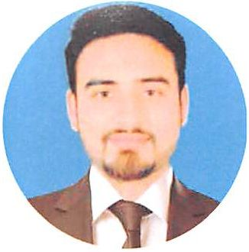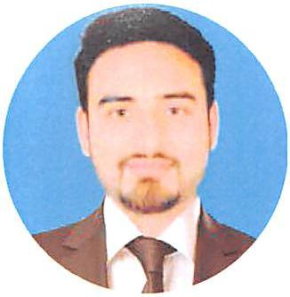

**SKILLS**

Graphic Designing

MS Office Research

**HOBBIES**

Travel

Music

m Reading ^ Writing

**PROJECTS**

* The Street Selling Project (Chicago) was a campaign to promote arbitrary caps to understand Consumer Behavior attributes. Conducted research analysis of HR structure of Maison Consulting (their pay ranges, pay mix, and other commission against the assigned positions).

Conducted a documentary titled, “How Orange Line Train system will Impact on Common Man”.

Wrote a new product launch document titled, “Gourmet Fish & Frozen Food”

**ACHIEVEMENTS**

« Certificate of Graphic Designing by ICT 2017 « Certificate of Appreciation by NEIU Chicago 2016 « Deans Merit Award at UMT 2014 Center for Entrepreneurship and Innovation (CENTIN) 2013