CURRICULUM VITAE
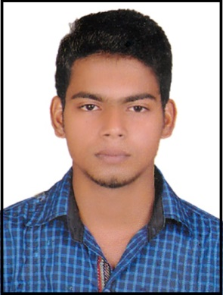
SHAFEEQ
Email ID: shafeeq.309962@2freemail.com

Career Objective
To excel in a suitable position by applying my experience and strive to words fulfilling the responsibilities assigned to me best perform in my field. I assure to up hold quality standard and I will be valuable asset to the organization.
Skill Profile:
- Good communication and interpersonal skills.
- Hard working team member.
- Have the ability to work for long hours.
- Have the ability to work under pressure.
Work Experience:
ACCOUNTANT| May 2012 - September 2014
AR Furniture & Crockery World, Malappuram, Kerala, India
Following are the actions / responsibilities that I undertook at AR Furniture & Crockery World
- Maintaining Ledger
- Maintaining Statement of account
- Issuing invoices and Payment follow up
- Analyzing accounts
- Income and Expenditure report
- Preparing balance sheet
Asst. ACCOUNTANT cum Salesman | October 2014 – till date
Real Gifts, Abu Dhabi, UAE
Following are the actions / responsibilities that I undertook at Real Gifts, Abu Dhabi
- Recording daily expenses, incomes
- Maintain the creditors’ accounts
- Assistance to main Accountant
- Guidelines to customer
- Sales promotion activities
- Record the purchase items
Skills and Qualifications:
- Energy Level, Dependability, Productivity, Customer Service, Professionalism, Attention to Detail, Customer Focus, General Math Skill, Informing Others, Basic Safety and Job Knowledge

Educational Qualification:
- Graduate in Bachelor of Commerce
- Calicut University, Kerala, India
- Higher Secondary School (Commerce)
- Board of Examinations Kerala Govt., Kerala, India
Language Skill:
- English, Hindi and Malayalam
- Arabic (Reading & Writing)
Computer Knowledge:
- Tally ERP9
- MS Office - Microsoft Excel , Word, PowerPoint
- Windows 10, 07 and XP
PERSONAL DETAILS:
Nationality : INDIAN
Religion : Islam, Muslim
Date of Birth : 29th May 1993
Marital Status : Single
Gender : Male
Height : 169 CMS

Passport Details:
Date & Place of Issue : 26th March 2014, India
Date of expiry : 25th March 2024
Visa Status : Employments Visa (Transferable)
Declaration:
I hope that above mentioned particulars will meet your requirements and if you have given a chance to serve you. I assure you that I can do my best duties interest in the company and the entire satisfaction of my superiors.

SHAFEEQ

