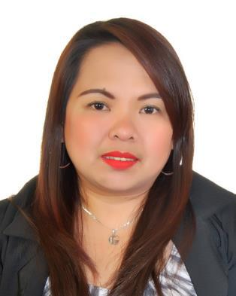
JOYCE

E-mail: joyce.311610@2freemail.com

Objective: To be able to contribute my knowledge and skills to the company, willing to accept every opportunity related to career growth and improvement.

PERSONAL PROFILE:

Birthday | : | August 8, 1979
Birthplace | : | Cavite City, Philippines
Age | : | 37 years old.
Civil Status | : | Single
Height | : | 5’ 2"
Weight | : | 60 kgs.
Religion | : | Catholic

WORKING EXPERIENCE:

1.) SPORTLAND FZCO

P.O. Box 4615, Bldg. EWTA 79, JAFZA, Dubai - UAE

SALES COORDINATOR (Converse, Ipanema, and Head)

July 13, 2013 up to September 22, 2016

- The Sales Coordinator interacts with sales, brand managers, and marketing services. This individual will also perform a range of support duties related to the operations of the marketing department.

- Develop sales tools and marketing collateral materials to support key marketing and sales initiatives.

- Work closely with wholesale and retail team to ensure all tactics align
- Provide marketing support related to ongoing company initiatives as needed

- Help with the coordination and set up of product launches and key marketing meetings.
- Assist with PO entry and receiving.
- Prepares product samples in the showrooms
- Coordinate in placing orders of the assigned brands to the supplier.

- Work closely with the logistics team in ensuring all the ordered goods of the clients are delivered/shipped.

2.) EMERSON PHILIPPINES

Laguna Techno Park, Sta. Rosa, Laguna

AI/ SMT MC/PRODUCTION LINE LEADER June 17, 2006 to 2013

- Manage and handles production and material center operator.

- Implement the standard procedure.
- Issue material based on lead time and requirements.
- Closed monitoring of productivity.

3.) DAISKIE MARKETING (Accredited Independent Telesales Agency of Standard Chartered Bank)

7/F F&M Lopez Bldg. 109 C. Palanca St. Legaspi Village, Makati City

Customer Service Representative (Outbound) August 16, 2002 to August 30, 2004

- Tasked in offering bank transaction such as trust fund and time deposit.

- Determines requirements by working with customers.

- I make calls to customers who have questions or concerns related to their purchase experience or product use and when problems arise on customer accounts.

EDUCATIONAL ATTAINMENT:

VOCATIONAL:

Computer Technician

(Hardware and Software Installation and Troubleshooting)

Cavite City Technical and Vocational School

Year 2003 (June) – 2003 (November)

COLLEGE:

BSBA Major in Banking and Finance

San Sebastian College Recoletos de-Cavite

Year 1999 - 2000

HIGH SCHOOL:

Cavite Natl. High School

Year 1992 - 1996

TRAINING AND SEMINAR

Line Leaders Course

Leadership training, October 07, 2008

Safety leadership, October 07, 2008

Business Ethics

Attitude towards business, February 09, 2013

RCCA and Effective Problem Solving

How to handle problem, May 08, 2013

SKILLS:

Knowledge in Oracle System

Computer Literate

CHARACTER REFERENCES:

Available upon request.

