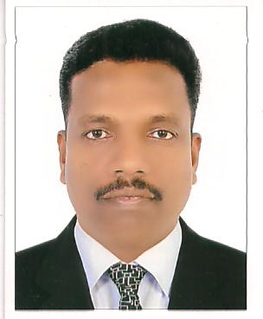
JOHNSON
DUBAI, UAE
Email: johnson.312306@2freemail.com

- Objective:
To obtain suitable vacancy where l can utilise my qualification skills & experience towards the growth of the organization.

- Educational Qualifications:
SSLC, Secondary school leaving certificate, Government of kerala,
Pre - degree, kerala university.

- Technical Qualifications :
ITI Electrical (Government ITI Chakkai, Trivandrum) kerala.

- Driving Status :
Light duty vehicles.
Ten years experience all over UAE.
- Other Qualifications :
Computer knowledge -MS office, lnternet.

Experience & Professional Training :
Total 15 years in Dubai.
2 years in Bright star safety equipments , worked as an Electrician (1999 -2001)
12 years in Penguin Engineering, Dubai as an Electrical Supervisor.
Currently working in Haydon MEC LLC from 1 Year as a MEP Supervisor

Work and Mode of work taken up by me :
Company: Haydon MEC LLC
Which is a Electromechanical company based in UAE,. Which has performed the projects viz,. N1R Abudhabi, Marsa Dubai and OPUS Tower etc.
Post: MEP Supervisor
Company : Penguin Engineering LLC, PVT Ltd.
About the company : lt is HSBC holding British management , multi - service MEP Company for Dubai Maritime city Workshops, V3 towers Jumeira lakes, Limitless building 4, Plot 50/51 Clarren Towers ,Abudhabi Airbase(Hangar), Saddiat Beach Club, Cleveland clinic Abudhabi etc.
Other Industrial, commercial, hospitality, retail&fashion and food&beverages projects.
Post : Electrical Supervisor

Job Description:
well knowledge in drawings &Schedules.
Specialist in Busbar installation.
Substations& LV Rooms
MDB, SMDB, DB and other power solutions.
Industrial and Domestic wiring.
Lighting and Dimming control systems.
All types of containment works.
AII types of cable works and terminations.
All types of electrical testing and reports.

Relative Works :
Fire alarms
Voice and Data
Door access and security systems
AV System and PAVA
BMS and Emergency lighting systems.
HVAC and Plumbing works
Personal Strength :
Adaptability, Hard working and reliable.
Communion skills : enjoy working in both team environment and independently.
Teamwork : expressing critical opinions with customers.
Self - motivation/management : Dependability, handled many things with excellent results although the time constraints.
Creativity : New ideas for lunching the event.

Personal Details:
Date of birth : 31- 05-1974.
Sex : Male .
Marital status : Married.
Nationality : lndian.
Languages known : English, Hindi, Tamil &Malayalam.

Declaration :
I hereby declare that the details given above are true to my knowledge.
Thanks & Regards.

