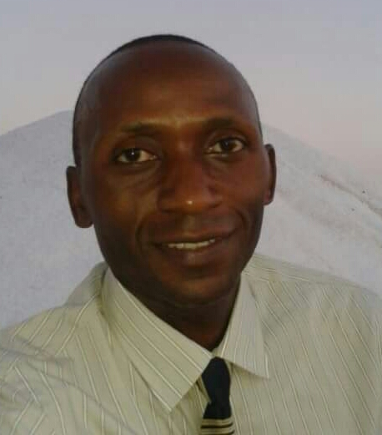
CURRICULUM VITAE

- PERSONAL DETAILS:
NAME : HOWARD
HOWARD.315480@2freemail.com
GENDER : MALE

- EDUCATION DETAILS:
Year | Award
1995-1997 | Diploma in business Administration & Management, Makerere Institute of Social Development.
1993-1995 | Uganda Advanced Certificate of Education (UACE)
1989-1992 | Uganda Certificate of Education (UCE)

- PROFESSIONAL DETAILS
Year | Title | Organization
2014- up-to-date | Security Personnel | Al Jaber Group of Companies, United Arab Emirates
2012-2013 | Procurement & Logistics Officer | Yambio Produce Company, South Sudan
2010-2012 | Chief Cashier/ Inventory Controller | Cellular Services(MTN Franchise ), South Sudan
2008-2010 | Finance Officer | Iganga Child Development Centre , Compassion International Uganda.
1999 -2005 | Accountant/Administrative Assistant | Morris Cerullo World Evangelism, Uganda
1996 - 1998 | Procurement & Logistics Officer | Hadoto Water & Sanitation, Uganda

WORK EXPERIENCE:
2014- up to date. Security personnel ; Aljaber Group of companies.
- Acting as an ambassador of the company to the client .
- Ensuring the security and safety of the people and property
- Preparing and compiling security report
- To observe and report security related issues
- To enforce the law.

2012- 2013. Procurement and Logistics Officer; Yambio Produce Company, South Sudan.
- Preparing and completing action plan
- Identifying and managing potential markets and suppliers.
- Developing warehouse operation system and resolving problems.
- Implementing productivity, quality and customer care service standards
- Preparing Annual budget
- Tracking the dispatch and deliveries

2010- 2012 Chief Cashier/Inventory Controller; Cellular Services Company limited (MTN Franchise) – South Sudan
- Making stock and purchase orders and receiving stock.
- Reconciling the daily stock balances with daily total sales
- Receiving cash and cheques from cashiers and carrying out bank transactions.
- In charge of reception and distribution of MTN products.
- Preparing daily and monthly stock and sales status reports

2008 – 2010 Child Development Officer In Charge of Finance; Iganga Child Development Centre - A compassion International Assisted Project – Uganda.
Maintaining Books of Accounts including cash books, voucher registers and posting entries to various accounts.
- Compiling project financial reports
- Preparing materials for budget estimates.
- Maintaining the staff payroll.
- Ensuring safety and proper management of all project assets by maintaining an up to date assets register.
- Responsible for the cognitive and economic development of the sponsored children and mobilizing opportunities for empowering care givers in income generating activities.
- Processing requests for supplies and maintaining up to date stores inventory and records.
- Visiting children in their homes to assess their situations and offering intervention where necessary.
- In-charge of sponsor/donor relations

1999 – 2005 Accountant/Administrative Assistant;
Morris Cerullo World Evangelism – Uganda
I handled various duties among which included the following;
- Receiving cheques and cash
- Writing cheques, balancing and reconciling cash books.
- Managing the Bank transactions
- In charge of transport
- Making correspondences and communications
- Supervising stock taking
- Carrying out general office administration
- Organizing meetings and taking minutes for staff meetings.
- Arranging and managing staff and members travel by making air ticket and hotel reservations, confirmation and visa applications.

1996 – 1998 Procurement and Logistics Officer; Hadoto Water and Sanitation Engineers – Uganda.
The duties among others included;
- Soliciting project resources and procuring them.
- Arranging delivery on the site of engineering materials such as pumping system, equipment, metal grills, bars etc.
- Supervising the work force at the site to ensure high quality work.
- Prudently monitoring over optimal levels of stock.
- Negotiating and purchasing high quality project inputs at fair prices.
- Identifying and advising the managing Directors of obsolete stock.
- Marketing the company services to organizations with water projects.

LANGUAGE PROFICIENCY;
Language Spoken Written
English Excellent Excellent
Luganda Excellent Excellent
Arabic Fair Poor

My core strengths and capabilities include but not limited to the following;
- Computer Literate in MS Word, MS Excel, MS Access, Power point and Internet.
- Writing Project Proposals
- Good Communication and negotiation skills
- Team player and enthusiastic grasper of new concepts.
- Self driven, self motivated, highly dependable and always ready to learn.
- Customer/Client focused, performer and committed to quality.
- Strong leadership and interpersonal skills and experience

MY OBJECTIVE
To protect and yield good results for the institution in order to achieve its goals.

