D A N I E L

S A L E S E X E C U T I V E | I N S U R A N C E S A L E S

An Insurance professional with more than 7 years of varied experience in divisions like general, medical, and motor insurance. With my varied experiences in IT and sales, I am actively seeking an opportunity as an Insurance consultant, Insurance coordinator, Banking, Insurance operations and Insurance sales.

E X P E R I E N C E

S A L E S E X E C U T I V E

D U B A I , U A E | 2 0 1 8 – P R E S E NT General Insurance | Medical Insurance

Seek out new clients and develop clientele by networking to find new customers and generate lists of prospective clients.
Confer with clients to obtain and provide information when claims are made on a policy.
Sell both medical and general type of insurance policies to businesses and individuals on behalf of insurance companies.
Customise insurance programs to suit individual customers, often covering a variety of risks.
Explain features, advantages and disadvantages of various policies to promote sale of insurance plans. Calculate premiums and establish payment method.

S A L E S E X E C U T I V E

D U B A I , U A E | 2 0 1 7 – 2 0 1 8

General Insurance | Medical Insurance

Under deputation to Noor Takaful Insurance ,

handing customer service including insurance-

mainly medical insurance through online portals over a

period of 4 months.

Acquire new clients, build and maintain ongoing relationships with existing clients.
Developed new collaborations with Amer Centers and related business setups.
Foreseeing clients' insurance needs, and advising them on the

best possible solutions to their insurance problems.

Organising and following up various client inquiries.

C O N T A C T
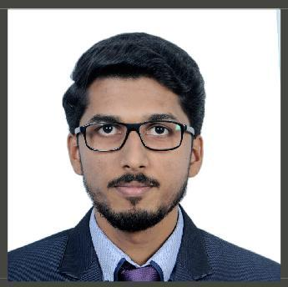

E m a i l : Daniel-316208@2freemail.com

N a t i o n a l i t y : I n d i a n

V i s a S t a t u s : E m p l o y m e n t V i s a

P R O F E S S I O N A L S K I L L S

C | C + + | H T M L

W i n d o w s X P | W i n d o w s 7 | W i n d o w s 8

M i c r o s o f t O f f i c e

T a l l y

D e s k t o p S u p p o r t -

W L A N | L A N

A d o b e P h o t o s h o p

A d o b e I n D e s i g n

A d o b e I l l u s t r a t o r

S Q L S e r v e r ' 1 4

. N e t | A S P d e v e l o p e r

P E R S O N A L D E T A I L S

D a t e o f B i r t h : 1 7 J u n e 1 9 9 1

M a r i t a l s t a t u s : S i n g l e

L a n g u a g e K n o w n :

E n g l i s h | M a l a y a l a m

^{E X P E R I E N C E} (continuation)

I N S U R A N C E A D V I S O R

I N D I A | 2 0 1 2 – 2 0 1 6
Life Insurance | Medical Insurance

Develop marketing strategies to highlight products to potential customers in a given geographic area.
Provide various types of insurance policies to businesses and individuals.
Attend meetings, seminars, and programs to learn about new products and services, learn new skills, and receive technical assistance in developing new accounts.
Building and maintaining business relationships with clients.

A C A D E M I C H I S T O R Y

Master of Business

Administration (Marketing)

| 2 0 1 4 - 2 0 1 6

RABINDRANATH TAGORE, I N D I A

B a c h e l o r s o f C o m p u t e r

S c i e n c e | 2 0 1 1 - 2 0 1 4

M G U N I V E R S I T Y , I N D I A

