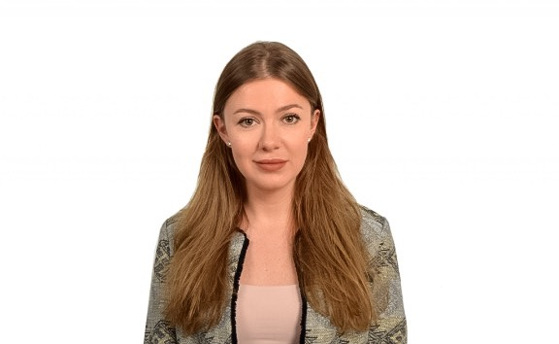
Iryna
Iryna.316632@2freemail.com

Professional Experience
Emirates Airlines January 2015 to May 2016
Customer Service Representative
- Taking calls globally and assisting customers with their travel needs.
- Researching travel options & presenting the best deals based on client requirements
- Issuing and amending of travel tickets.
- Offering and booking other services such as chauffeur driven cars, meals and seats etc...)
- Managing high valued customer profiles using the Emirates Customer Relationship Management System (CRM).
- Ability to achieve the Emirates sales targets and objectives.
- Consistently delivering on the Emirates brand promise by providing unrivalled customer experience.
Tez Tour Travel Agency September 2013 to January 2015
Travel Consultant
- Offering holidays to a wide variety of long haul luxury destinations, including the Indian Ocean, Arabian Gulf, Egypt & Africa and Far East.
- Handling incoming calls from direct customers and travel trade.
- Ensure all bookings & reservations are processed accurately.
- Filing, photocopying and general administrative duties.
- Building strong relationships with clients.
- Up selling relevant add-ons, like, insurance, excursions, currency etc.
- Negotiating corporate and best rates with hotels.
Education and Training
- Belarusian State Linguistic University, Belarus
Contemporary foreign languages, 2014

- Emirates Airline, United Arab Emirates
Emirates Foundation programme Certificate
Computer Skills and Languages
- Proficiency in Microsoft office (Word, Excel, Outlook and PowerPoint)
- Fluent in Russian, English, Spanish. Basic knowledge of Arabic
Personal Information
- Date of Birth: 12 February 1992
- Nationality: Belarussian
- Driving License: valid UAE

