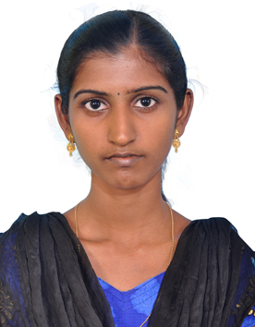

VINITHA
Email: vinitha.317763@2freemail.com
B.E,Civil Engineering

CAREER OBJECTIVE
To work in a firm with a professional work driven environment where I can utilize and apply my knowledge, skills which would enable me as a fresh graduate to grow while fulfilling organizational goals.

ACADEMIC QUALIFICATION

Qualification | Board/University | Year of passing | Name of Institution
B.E (Civil Engineering) with 76.58% | Anna University Chennai | 2015 | St.Xavier’s Catholic College of Engineering,  Chunkankadai.
HSC with 84.42% | Tamil Nadu State Board | 2011 | Ponjesly Public Matriculation Higher Secondary School.
SSLC with 83.2% | Tamil Nadu State  Board | 2009 | Ponjesly Public Matriculation Higher Secondary School.

AREA OF INTEREST

    - Construction Engineering
    - Design Engineering

.COMPUTER LITERACY

- Windows 8,7,XP
- Auto CAD (Civil)
- Revit Architecture
- 3DS Max
- Staad.Pro V8i
- Microsoft Office

EXTRA –CURRICULAR ACTIVITIES

- Attended 5days In-plant training at V.O. Chidambaranar Port Trust, Tuticorin.
- Attended cultural activities during schooling and college

PROJECT DETAILS

Mini Project Title : Plan, analysis and design of a car showroom

Software used : Auto CAD, Staad.pro v8i

Description : The main aim of the project is to plan, design and analyze of a car showroom. The structural members like slabs, beams, columns and footing are designed by limit state method with the help of national building code, IS 456-2000, IS-875(part-1 & part-2) and Sp-6. The various load combination such as live load, dead load and floor finish load were taken as per IS:875

Main Project Title : An experimental study on the behavior of reinforced High Performance Concrete Column confined with Glass Fibre Reinforced material

Description : The aim of the project is to investigate the effects of GFRP confinement in reinforced HPC column specimens. To study the changes in ultimate compressive load carrying capacity of Reinforced HPC column specimens confined with GFRP. To study the effect of GFRP strengthening on the ultimate compressive load carrying capacity in pre-damaged HPC column and to study the stress-strain behavior of column confined with GFRP.

INTERPERSONAL SKILL

  - Ability to rapidly build relationship and set up trust.
  - Confident and Determined
  - Quick Learner
  - Good Listener
  - Ability to cope up with different situations.

PERSONAL DETAILS

- Date of Birth : 7th January 1994

- Gender : Female

- Marital Status : Single

- Nationality : Indian

- Language Known : Tamil & English

- Interest & Hobbies : Gardening, Drawing, Listening music, Reading books.

PASSPORT DETAILS

- Date of Issue : 25/07/2013

- Date of Expiry : 24/07/2023

DECLARATION

I do hereby declare that the above information is true to the best of my knowledge.

Place: Nagercoil Signature

(S.Vinitha)

