Bindu
Bindu.319109@2freemail.com
Curriculum Vitae
Financial Controller | Cost & Budget Management | Financial Auditor
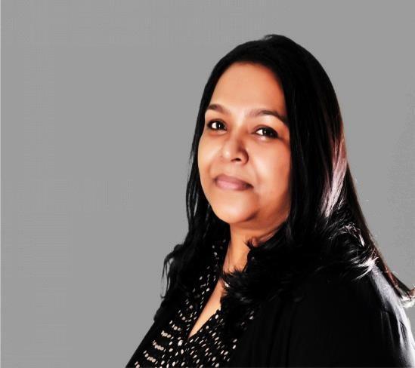
CA Inter |Masters (Finance, Management, Marketing & Computer Applications)
AN OVERVIEW
- An Achievement-driven Financial Controller & Manager with over 20 years of experience and proven track record of contributions leading to strategic implementation, costing, budgeting & forecasting,KPI analysis,auditing, heightened productivity and enhanced internal controls-
- Know-how & involvement in Direct & Indrect Taxes from India.
- Demonstrated excellence in achieving operating excellence and improving bottom line profit; specialty in developing and implementing financial controls, inventory controls, policies& processes and introducing new concepts and systems for achieving considerable cost reductions.
- Solutions oriented approach with excellent relationship and time management skills;efficient team leader striving consistently for delivering the responsibilities and offer quality work by streamlining finance and accounts operations. in achieving both corporate and personal goals in diverse cultures.
CORE COMPETENCIES
- Prepare, examine, and analyses accounting records, financial statements and other financial reports to assess accuracy, completeness, and conformance to International Financial Reporting and procedural standards.
- Analyses business operations, trends, costs, revenues, financial commitments, and obligations to provide advice for optimization.
- Develop, maintain, and analyses budgets, preparing periodic reports that compare budgeted costs to actual costs ensuring bestpractices and compliance of company standards and principles.
- Produce special insightful analysis on specific areas of business performances as and when required by various departmentheads through detailed presentations.
- Maintain day to day financial control of the services within the prescribed budget limits, procedures, policies, etc. supervisingthe daily accounting functions and cash management.
- Participating in corporate planning, including long-term forecasts, feasibility studies, the allocation of resources and financialplanning for business wide projects.
- Preparation of product and customer wise revenue & profitability report by proper apportion of direct expenses & allocationof indirect expenses.
Professional Experiences
Group Financial Controller (Audax Investment Group LLC,Dubai)
July,2012- Current
(A UAE based company with branches all over UAE and franchisees outside. The Company engages in the provision Beauty Management, Retail Trading , Franchisees & New Venture Investments with unique premium brand names)
Key Achievements &Contributions:
- Directly involved in the compilation and formulation the company evaluation by providing accurate financial data required and could provide all required information.
- Improvements in operating expenses done through providing information and analysis to facilitate a major corporate reorganization.
- Monitoring the key performance indicators and analyses causes (efficiency, losses, timings, products rotation, securitystock levels etc).
- A flexible and realistic costs system established helped on reducingor eliminating costs with no added value, to eliminate unprofitable activities, customers or products.
Group Finance Manager (Audax Investment Group LLC,Dubai)July,2011- June, 2012
Key Achievements & Contributions:
- Directly involved in the compilation and formulation of franchisee development programmes by providing accurate financial data required and could provide all required information.
- Successfully improved profitability through specific policy implementation and effective interaction with management, operations, and staff.
Chief Accountant (Audax Investment Group LLC,Dubai) July,2010- June, 2011
Key Achievements & Contributions:
- Formulated company policies and procedures within the group and centralized the inventory system by giving the vision, policy, measures and strategy.
- Established standard (IFRS)accounting policies and procedures and implemented ERP accounting system.
Project Accountant (Abbott Laboratories S.A -Gulf /Levant Region)
Mar, 2009- Mar, 2010 (short term contract)
(A diversified multinational health care company that discovers, develops, manufactures and markets innovative products and services that span the continuum of care from prevention and diagnosis to treatment and cure. Headquarter in north suburban Chicago; the company helps people around the world in more than 130 countries)
Chief Accountant (Motivate Publishing, Dubai)
Mar, 2007 – Feb, 2009
(Major publishing company,( A Joint Venture from Al Tayer Group) of entertainment, life style and business magazines, Events management, corporate brochures, cinema advertising, and books publishing (with approximately 250 multinational employees).
Chief Accountant (Desert City Holidays LLC, Dubai)
Mar, 2004 – Feb,2007
(A group company with travel & tourism and trading operations in DUBAI & INDIA).
Auditor/Audit Manager Venkatesh & Co, Chartered Accountants
1993-1996&1998-2004
(A leading audit company in Chennai, India with diversified company, bank & government audits)
Qualifications, Certifications & Trainings
- Master in Finance, Management & Computer Applications
(Passed with Distinction)Mahatma Gandhi University, Kerala, India (1996-1998)
Subjects:
Financial Management
Operations Research for Management
Marketing Management
Computer Applications
Business Economics
Applicable MathematicsApplicable Statistics
Project works:
- The major project work was in Financial Management on working capital management.
- Survey on hospitals and the medical services delivered for a district
- Bachelor In Science - B. Sc.(Passed in First Class)
Mahatma Gandhi University, Kerala, India (1986-1989)
Subjects: Chemistry, Mathematics, Statistics,Physics
- CA Article ship training (3 years) and Intermediate.(1989-1993)
Curriculum:
Financial Reporting
Financial Management
Auditing & Management Accounting
Corporate & Tax Laws
Direct & Indirect Taxes
Information System Control & Audit
IT SKILLS
- ERP: financial and cost modules, other accounting systems:
- POS Software’s, Inventory& Accounting Modules
- MS Office(Outlook, Word, Power Point, Excel)
- Programming languages (FORTRAN & C+)
PERSONAL PROFILE
- Date of Birth: 8th October.1968
- Linguistic Proficiency: English Hindi, Malayalam, Tamil
- Driving License: Valid UAE and Indian
- Nationality: Indian
- Visa: UAE (Employment)

