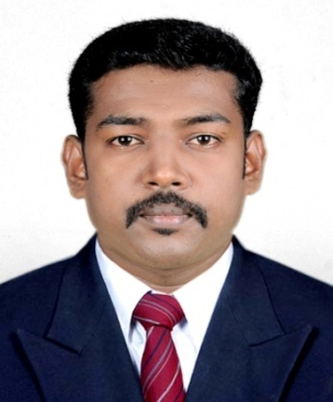
VISAL C S
DUBAI
0555728301,919526608277 (IND)
visalcs2050@gmail.com

User ID : 0015910653

Career Objective

To contribute my experience and caliber and to achieve the highest level of proficiency for a growth oriented and reputed organization that will provide professional working environment and carrier advancement prospects.

Summary

- Overall 6+ years of experience years in Finance & Accounting.
- 2 Years working experience in Dubai as an Accountant
- Strong knowledge in Accounting Software
- Strong knowledge in SAP FI Module
- I have strong knowledge in financial and business acumen and a proven track record of maintaining long term business.
- Excellent time management skills with proven ability to work accurately and quickly priorities coordinate and consolidate tasks whilst simultaneously managing the diverse range of function from multiple sources.
- Excellent communication skills (both written as well as oral)
- Presentation and Team management skills
- Spontaneous ability to adapt to different working environments
- Linguistic Capabilities are
- English : Fluent
- Hindi : Intermediate
- Arabic : Beginner

PROFESSIONAL EXPERIENCE
RIO INTERNATIONAL LLC, DUBAI
FROM NOV 2013 – JAN 2016

DESIGNATION: ACCOUNTANT

DUTIES ANS REPOSIBILITIES
- Processing of different types of invoices PO Non PO ,credit memo and debit memo
- Interacting with customers through mails on queries
- Preparation stock ledgers
- Handling cash transaction
- End Day End Report with that of vouchers
- Preparation of Salaries
- Finalisation of Accounts

POPULR VEHICLES AND SERVICES, KERALA, INDIA
FROM MAR 2012 – APR 2013

DESIGNATION: EXECUTIVE FINANCE AND ACCOUNTS

DUTIES ANS REPOSIBILITIES
- Controlling and management of Outlets.
- Preparation of monthly reports including trail balance and profit and loss accounts.
- Submission of monthly returns of all branches.
- Inter-Branch Reconciliation.
- Verify bank Reconciliation.
- Preparation of wages and Salaries.
- Finalisation and consolidation of accounts.

GLORIYA ENTERPRISES (AUTHORISES LENOVO SERVICE CENTRE), INDIA
FROM APR 2009 – JAN 2012

DESIGNATION: ACCOUNTANT

DUTIES ANS REPOSIBILITIES
- Verify day end reports with that of vouchers.
- Prepare regular reports and summaries of accounting activities.
- Assist in preparing periodic trail balance.
- Handled Reconciliation.
- Coordinate with auditors & furnish necessary information for auditing.
- Report irregularities/discrepancies to the Senior Accountant.

Academic Education

2011 | M.Com (Completed)  M.G. University, Kottayam, Kerala, India
2003-2006 | B.Com  M.G. University, Kottayam, Kerala, India
2001-2003 | Plus Two  Govt. Higher Secondary School, Pampady,India
2001 | SSLC  Board of Public Examination, Govt. of Kerala, India
Technical Skills

SAP FICO  User ID:0015910653 | Certified as Financial Accounting with SAP ECC 6.0 EHP6  1 year Experience
Tally ERP 9 | 7 year Experience

Personal Details
FATHER NAME : C N SASIDHARAN
DATE OF BIRTH : 08.05.1986
AGE : 30
SEX : MALE
NATIONALITY : INDIAN
RELIGION : HINDU
MARITUAL STATUS : SINGLE
PASSPORT DETALS
PASSPORT NO : K8002208
DATE OF ISSUE : 22.02.2013
DATE OF EXPIRY : 21.02.2023
PLACE OF ISSUE : COCHIN, (INDIA)
SELF APPRISAL
As an overview, I am a result-oriented self-starter, flexible and effective communicator, problem solver, with ability to focus on solution and remain claim in crisis situation. I am organized, proactive and aspiring towards improving current procedures.
PLACE: DUBAI Yours Sincerely

DATE: 01-09-2017 VISAL C S

